Detecting Fraud Signals in Centers for
Medicare & Medicaid Services Data
Sabrina Woo, BioHealth Analytics
Love Ayinde, High-Performance Computing
Narsim Kamath, High-Performance Computing
Cameron Kass, High-Performance Computing
DSA Mentors: Dr. Ilker Ersoy and Dr. Timothy Haithcoat

Subject Matter Experts:
Director Arvids Petersons of the Missouri Medicaid Fraud Control Unit; Missouri Medicaid Audit and Compliance team, including Director Richard Ferrari, Darla Weekley, Colin Murdick and Jeffrey Rex; Lucas Gallardo from Alivia Analytics.

Abstract
Fraud is a pervasive and complex problem within the United States healthcare system necessitating increasingly robust detection methods. Our approach uses an analytical framework that integrates Centers for Medicare & Medicaid Services (CMS) Open Payments data, CMS Durable Medical Equipment, Prosthetic Devices, Prosthetics, Orthotics, & Supplies (DMEPOS) program utilization data, and the Department of Health and Human Services Office of Inspector General’s (OIG) List of Excluded Individuals/Entities into a standardized dataset from which we extract interpretable, specialty-level fraud risk signals for participating providers in Missouri and bordering states during calendar years 2021 through 2023. We apply an explainable hybrid model pipeline using Isolated Nearest Neighbor Ensemble and XGBoost to determine baseline “normal” behavior across our focused population, then flag providers who have a higher estimated likelihood of fraud risk without needing to utilize large numbers of confirmed fraud labels. For transparency, the score is paired with top contributing anomaly factors, enabling faster, more consistent investigative prioritization. The final model delivered a 50x lift over the fraud prevalence baseline and maintained a 10% confirmed fraud hit rate among the top 100 flagged providers. We cross-reference our results with Missouri’s list of active Medicaid providers to identify overlaps with high-risk providers participating in the Medicare DMEPOS program and integrate our findings into an interactive dashboard equipped with an agentic AI Model Context Protocol framework that accesses OIG and Missouri Secretary of State websites to improve the Missouri Medicaid Fraud Control Unit’s ability to access reports, audits, investigations and oversight findings.

Keywords
Class imbalance, DMEPOS, Fraud Detection, Medicare, XGBoost

Intended Audience, Problem Background, Literature Review, and Aims / Objective

Intended Audience
Our project is designed for a broad network of fraud prevention stakeholders, including CMS Medicare fraud teams, the Office of Inspector General (OIG), State Medicaid Fraud Control Units (MFCUs), and state program integrity units. The CMS Medicare Fraud Strike Force, jointly led by the Department of Justice (DOJ) and the Department of Health and Human Services (HHS) OIG, targets large-scale Medicare fraud schemes. Supporting these enforcement efforts, state program integrity units within Medicaid agencies focus on preventing improper payments, conducting audits, and referring suspicious cases for further review. State Attorneys General (AGs), and MFCUs investigate and prosecute fraud, waste, and abuse in federally funded healthcare programs through both criminal and civil actions. Collectively, these entities form a unified system dedicated to protecting public healthcare funds and preserving the integrity of Medicare and Medicaid programs.
This project was developed in direct collaboration with two of these audiences: the Missouri Medicaid Fraud Control Unit (MFCU) and the Missouri Medicaid Audit and Compliance (MMAC) department. These teams currently receive cases primarily through human referrals, federal and national networks, and purchased third-party software. In practice, their investigators face three compounding challenges: too many potential cases to review with limited staffing, difficulty distinguishing genuine fraud from legitimate billing errors, and a structural preference toward high-dollar or legally straightforward cases meaning subtler fraud patterns frequently go uninvestigated. The final product of this project must therefore be explainable, easily consumable by non-technical users, and geographically focused on Missouri and its bordering states, where our stakeholders have enforcement jurisdiction.
More broadly, the audience extends to any federal or state agency tasked with program integrity in Medicare or Medicaid. Because fraud patterns in one program frequently mirror those in the other, fraudsters often bill both simultaneously. Findings derived from the Medicare DMEPOS program carry direct relevance to Medicaid oversight as well. This cross-program applicability means our outputs can serve as investigative leads not just for MMAC and MFCU but also for regional CMS contractors and OIG field offices conducting parallel reviews.
The impact of this project carries both direct and indirect consequences. Preventing fraud, waste, and abuse (FWA) in socially funded programs such as Medicare and Medicaid provides an indirect financial benefit to all U.S. taxpayers by preserving public funds and ensuring the long-term financial sustainability of these programs. These programs together disbursed over $66 billion in improper payments during fiscal year 2025 alone. Directly, the project provides fraud investigation teams with a data-driven lead generation tool, surfacing high-risk providers and uncovering patterns that may indicate emerging national fraud schemes. Collectively, these outcomes reduce the systemic risk of undetected FWA and strengthen institutional accountability across the healthcare system.

Expected and Desired Outcomes
The project produces three concrete deliverables, each directly responsive to the operational needs of our stakeholder audience.
1. A Dashboard with an AI-Powered Search Assistant
The primary deliverable is an interactive, web-based fraud risk dashboard designed to reduce the investigative burden currently placed on MMAC and MFCU staff. A recurring friction point identified through our stakeholder conversations was the volume of browser tabs investigators must manage when cross-referencing providers across the OIG website, CMS databases, state business records, and audit reports each requiring a separate manual search. Our dashboard consolidates these sources into a single interface, presenting provider-level fraud risk scores, ranked lists of flagged providers, top contributing risk factors, and an AI-powered search assistant built on a Model Context Protocol (MCP) framework. The AI assistant allows investigators to query the OIG website and related federal sources in natural language, returning a citable, traceable response.
2. Visualizations Highlighting Key Fraud Signals Across Provider and Supplier Datasets
The second outcome is a suite of interpretable visualizations that communicate which billing behaviors strongly distinguish fraudulent providers from legitimate ones across our referring provider and billing supplier datasets. These include distributional comparisons of top service codes billed by excluded versus non-excluded providers, where our analysis found that the most common service codes among fraudulent referring providers were significantly more prevalent than in the general provider population. It was suggested by our external mentors, Director Arvids Petersons and the Missouri Medicaid Audit and Compliance team, to focus on visualizing billing spikes in our dataset for sudden, atypical surges in claim volume. Beyond spike detection, the visualizations also surface manufacturer payment patterns to providers, flagging payment categories identified as worth further investigation, as well as specialty-level correlations between Open Payments financial relationships and fraud risk. Together, these visualizations transform model outputs into an evidence summary that a non-technical investigator can read, interrogate, and act on without requiring any knowledge of the underlying models.
3. A Full Machine Learning Pipeline for Fraud Risk Scoring
The third outcome is the end-to-end machine learning pipeline that underlies the dashboard and visualizations. The pipeline begins with an unsupervised anomaly detection stage applied to Open Payments manufacturer-to-provider financial transaction data, using Isolation Forest, ECOD, and INNE to surface statistically atypical payment relationships at the provider level without requiring fraud labels. These anomaly flags are then carried forward as engineered features into the supervised modeling stage. The supervised pipeline proceeds as follows: a 60/40 stratified train/test split is applied with NPI-level group constraints to prevent data leakage across years; feature selection is performed using built-in importance metrics across CatBoost, XGBoost, LightGBM, and Decision Tree classifiers to identify the top-k features; hyperparameter tuning uses a StratifiedGroupKFold cross-validation scheme with 5 folds, ensuring each fold maintains class balance while keeping all records for a given provider in a single split; and final models: XGBoost, LightGBM, Logistic Regression, and SVM. The models are then evaluated on the held-out test set using AUPRC as the primary metric, with Macro F1, AUC-ROC, Macro Precision, and Macro Recall reported as secondary metrics. Each provider ultimately receives a composite fraud risk score scaled between 0 and 100, aggregating outputs across models to produce a ranked triage list suitable for operational use by MMAC and MFCU investigators.

Problem Background & Literature Review

Background
The creation of income security and health care programs in the 20th century produced a class of programs that the U.S. Congress formally defines as mandatory or direct spending [1]. A mandatory spending program is a federally funded program which is not funded via annual appropriations bills, and Medicare and Medicaid are examples of mandatory spending programs created to provide individuals with health insurance. Healthcare fraud, waste, and abuse (FWA) drain billions of taxpayer dollars each year and undermine the integrity of these programs, posing a persistent challenge to the U.S. healthcare system. Fiscal year 2025 estimates indicate that improper Medicare Fee-for-Service payments totaled $28.83 billion [2]. One particularly vulnerable area involves Durable Medical Equipment, Prosthetics, Orthotics, and Supplies (DMEPOS), which includes items such as wheelchairs, knee braces, and other medical supplies. According to the Office of Inspector General (OIG), Medicare payments for DMEPOS exceed $7 billion annually, and this category remains “a major concern” for FWA in federal programs [3].
The U.S. legal and enforcement landscape has increasingly prioritized combating FWA, establishing it as a strategic focus of federal healthcare oversight. On June 30, 2025, the U.S. Department of Justice announced the largest healthcare fraud takedown in U.S. history, charging 324 defendants in schemes amounting to $14.6 billion [4]. Although there has been a revitalized focus, FWA investigations rely heavily on public hotline referrals, interagency recommendations, manual audits, and retrospective reviews, which are often slow, resource-intensive, and reactive rather than preventive. As a result, fraud prevention efforts remain insufficient to curb its proliferation within the Medicare DMEPOS program aided by emerging technologies. On February 27, 2026, CMS deemed a national moratorium on the enrollment of medical device suppliers into this program necessary to prevent or combat FWA [5].
Medicaid is a state-administered program that is funded jointly by states and the federal government to provide health coverage to low-income adults, children, pregnant women, elderly adults, and people with disabilities [6]. CMS estimates improper payments for Medicaid totaled $37.39 billion during fiscal year 2025 attributing 77.17 percent of which to insufficient documentation [2]. While payments with insufficient documentation are not generally indicative of fraud, they suggest that the program’s payment controls do not effectively safeguard against improper disbursements. Fraudsters have an opportunity to exploit this weakness and potentially receive payments by submitting fraudulent claims. They may choose to target Medicaid and Medicare simultaneously due to the similarities between these programs, and as such, fraud patterns occurring in one program are reasonably likely to appear in the other. Our work is therefore relevant to Medicaid Fraud Control Units (MFCUs), which are teams of investigators, attorneys, and auditors that typically operate under the Attorney General’s office in each of the 50 States, District of Columbia, Puerto Rico, and the U.S. Virgin Islands to investigate and prosecute Medicaid provider fraud [7].
Our project will explore how data-driven approaches can identify providers whose billing and financial behaviors deviate from expected norms enabling fraud investigators to discover high-risk providers through more efficient automated processes. Using a machine-learning framework to analyze provider-level claims data and manufacturer financial transaction data to identify potential DME-related fraud, we position anti-fraud agencies to stay ahead of emerging AI-driven schemes.

Traditional Fraud Detection and Its Limitations
Traditional fraud detection in healthcare and finance has shifted from manual audits and rule-based checks toward machine learning methods [8]. Of these machine learning approaches, supervised learning relies on labeled fraudulent and non-fraudulent cases to train models that classify future claims or transactions as fraud or normal. Unsupervised learning is commonly used to detect anomalous patterns or identify outliers. The most common supervised models are Random Forest, tree-based models, Logistic Regression, Support Vector Machines (SVM), Naïve Bayes, neural networks, and graph neural networks ([8], [9], [10]). For unsupervised methods, k-means, k-Nearest Neighbors, Local Outlier Factor, PCA, one-class SVM, Isolation Forest, and DBSCAN ([8], [9], [10]). In general, supervised learning is the dominant approach in fraud literature in healthcare and finance ([8], [9], [10]). This is then followed by unsupervised methods while hybrid approaches are far less frequent.
The overall limitations of current machine learning approaches in the healthcare and fraud space are like those encountered in rare-event modeling. Fraud data is scarce and expensive to obtain since confirmed fraud cases require investigation or expert validation; this leads to a major class imbalance [8], [9]. Additionally healthcare data is often very complex, text-based, inconsistent, and contain many missing values [9]. Machine learning models applied in fraud can also produce costly misclassifications, especially when false negatives allow fraudulent activity to go undetected or false positives trigger unnecessary investigations [9]. Finally, many methods can be a black box and lack explainability for investigators. These limitations are important to consider before examining how fraud investigations are initiated and carried out operationally.
In general, fraud investigations for private health industries are generally initiated through claims analytics, algorithms, or audits [8]. Alternatively, fraud investigations for MFCUs are generally kickstarted by hotline tips, interagency referrals, and federal investigations ([11], [12]). Current investigation methods at the state level are held up by bureaucracy and budget restraints. Specifically, for MFCUS’s, budgets of the team are dependent on federal allocations and are subject to regulatory limits tied to state Medicaid program expenditures. [12]. As a result, while private health industries may rely on higher staff numbers and high-tech detection systems, MFCUs face structural obstacles for fraud investigations.
These barriers are not limited to just resources; they also extend to the adoption of newer technologies. State and local governments have been slow to adopt Artificial Intelligence (AI) software or tools due to explainability concerns, lack of trained staff, and institutional pressures [13]. However, pilot cases of AI uses have been shown to improve the work efficiency of administrative teams [14]. Primarily, these cases have involved generative AI usage for legal research, document search, analytical reporting, and document processing [15], [16]. AI assistants, or AI tools that are able to perform basic tasks given the role of the user, have also been known to show efficiency gains and streamline task completion [16].

Similar Work

Previous Findings
Two studies conduct a comprehensive survey of the state of healthcare fraud detection research. Du Preez et al. [8] conducted a systematic literature review of machine learning approaches used in health insurance fraud detection, examining data sources and methodologies reported over the past 20 years. This comprehensive review highlights key challenges in the field, available datasets, methodologies, and opportunities for future research. The authors analyze applications of supervised, unsupervised, and hybrid learning in the subject space and detail the most common features from available healthcare datasets. We draw upon the large list of software tools and libraries these authors curated from previous studies. Li et. al. [9] provide a comprehensive survey of statistical methods for healthcare fraud detection, examining both supervised and unsupervised approaches to identifying fraudulent behaviors in medical data. The paper categorizes supervised methods, which require labeled datasets of known fraud cases, including techniques such as neural networks, decision trees, and Bayesian networks, as well as unsupervised methods, which detect anomalies or outliers without pre-labeled data, using clustering and anomaly detection algorithms. The authors emphasize the importance of data preprocessing, including cleaning, normalization, and feature selection, to improve the accuracy and reliability of fraud detection models. They also review the strengths, limitations, and applications of various statistical techniques, crucially highlighting how they might be combined to enhance detection performance.
The authors Bauder and Khoshgoftaar have conducted extensive machine-learning studies using Medicare data to perform fraud detection. Khoshgoftaar co-authored a 2023 publication [17] on leveraging Centers for Medicare & Medicaid Services (CMS) data for Medicare Part B, Part D, and Durable Medical Equipment, Prosthetics, Orthotics, and Supplies (DMEPOS) programs during the 2013 – 2019 program years to perform fraud classification with extreme gradient boosting (XGB) and random forest (RF). We adopt the subset of exclusion rules from this study which were applied to the List of Excluded Individuals and Entities (LEIE) for labeling records as fraudulent. We also follow this publication’s blueprint for engineering features from the Medicare programs’ datasets to produce many of our engineered features. Bauder and Khoshgoftaar jointly published a 2018 study using random forest models while investigating how class imbalance in Medicare big data affects fraud detection [18]. They applied random under sampling to create seven different class distributions (From 99.9:0.1 to 50:50) and test random forest performance finding their model trained on the distribution of 90:10 (non-fraud: fraud cases) achieved the best AUC score. We explore a similar range of class distributions for random undersampling in our modeling.
Tajrobehkar et al. [19] explored the use of machine learning to improve Medicare fraud detection specifically targeting overutilization schemes in which providers manipulate claim documents to obtain larger payments from Medicare than they are entitled to. The authors sought to overcome the limitations of traditional methods that rely heavily on LEIE datasets and manual audits, arguing that this approach tends to ignore subtle patterns and fixates only on extreme cases. They created a labeled dataset in ophthalmology with the help of medical billers and physicians including features that were designed to capture realistic overutilization patterns. They tested multiple machine learning models, such as K-nearest neighbor (KNN), logistic regression (LR), support vector machines (SVM), extreme gradient boosting (XGB), and multilayer perceptron (MLP). However, the scalability of the authors’ approach is highly limited, as they rely on a small, expertly-curated datasets which would require labor-intensive expert-labeling to scale to the vast array of specialties spanned by Medicare providers. Their models also generally fail to distinguish legitimate overutilization from actual fraud.
Bairy et al. [20] focused on detecting healthcare fraud using unsupervised learning methods which are machine learning algorithms that do not rely upon a target label. They apply techniques such as Isolation Forest, Local Outlier Factor (LOF), kNN-based outlier detection, and autoencoders to identify anomalous billing and provider behaviors, comparing which approaches most effectively flag suspicious patterns. We integrate these unsupervised methods into our methodology to surface abnormal providers or claims as high-risk cases and overcome limitations of ground truth labels which rely on the LEIE. Our unsupervised learning results feed into our fraud risk scoring system and support our dashboard visualizations, strengthening fraud detection even when labeled data is sparse. Liu and Vasarhelyi [21] utilized an unsupervised clustering model that incorporates geo-location data. Using claims-level data purchased from CMS, their models calculated the distance between the providers and the beneficiaries to identify unusual patterns, such as patients travelling large distances for service. They then clustered the providers and claims based on the geography and service patterns to highlight outliers without requiring labeled data. The authors emphasized that combining unsupervised clustering with supervised models could enhance the predictive power which is an approach we adopted. We do not however, implement the geospatial methods used by these authors as funding constraints and restrictions on the use of patient data prevented us from accessing requisite data.
Hamid et al. [22] addressed the challenge of healthcare insurance fraud detection by designing a hybrid two-stage pipeline that combines association rule mining with unsupervised anomaly detection. Using the Apriori algorithm, they first extracted frequent patterns in claims, then applied methods such as Isolation Forest, Cluster Based Local Outlier Factor (CBLO), Ensemble Correlation-Based Outlier Detection (ECOD), and One-Class SVM to flag usual behaviors. Using the Silhouette score, the methods that perform best are CBLOF and Isolation Forest. This approach highlights how reducing the data into transaction rules before anomaly detection improves both efficiency and accuracy. We apply anomaly detection methods used by these authors to uncover outlier providers and use flagged anomalies as variables that influence our fraud risk scoring system.
Sethi [23] focused on the broader concept of risk scoring in healthcare analytics, particularly how machine learning models can assign quantitative risk scores to entities such as patients, providers, and clinical processes to predict high-risk outcomes. The primary focus was on clinical risk, such as hospital readmission and compliance issues. The paper emphasized model interpretability, feature selection, and regulatory compliance as key considerations when implementing risk scoring systems in real-world healthcare settings. The score was determined by integrating multiple predictive features from historical and real-time data, which may include billing patterns, claim volumes, and frequency of high-cost services, unusual service combinations, prior sanctions or exclusions (like in the LEIE database), and regional socioeconomic indicators. Each feature is typically standardized or normalized to ensure comparability and may be weighted based on its predictive importance, which can be determined through machine learning techniques. The model calculated an overall risk score for each provider, usually scaled between 0 and 1 or 0 and 100, where higher scores indicated a higher likelihood of fraudulent or anomalous behavior. Advanced implementations could also provide feature-level contributions, explaining which factors most influenced a provider’s score, enhancing interpretability and enabling stakeholders to understand why a provider is flagged as high risk. In practice, scoring can be used to prioritize investigations, allocate audit resources efficiently, and feed visual dashboards that highlight high-risk providers and regions, while maintaining regulatory compliance and transparency. We combine predictive modeling with scoring to quantify fraud likelihood systematically, compare providers across multiple dimensions, and produce actionable insights for CMS, OIG, and MFCUs.
Kaddi and Patil [24] addressed the challenges of detecting fraud in healthcare claims within imbalanced datasets. Due to the evolving nature of fraudulent schemes, standard rule-based fraud detection methods are ineffective. Therefore, the authors proposed an ensemble learning approach to overcome this major hurdle. They utilized a stack ensemble learning model which combines multiple base classifiers to improve accuracy. Given the extremely small proportion of fraud cases, the authors employed Synthetic Minority Over-sampling Technique (SMOTE) to balance the dataset and improve performance. The performance of the model was compared with individual classifiers, and the experiment showed that the ensemble learning approach significantly outperforms the rest. We consider this model a reliable benchmark to compare different approaches due to its strong predictive capabilities.
El-Lanky and Chrimes [25] presented a big data analytics approach to detecting fraud in U.S. Medicare claims, emphasizing how the massive scale of healthcare service data can be effectively processed to uncover irregular billing and provider behaviors. They address the challenges of big data by leveraging parallel computing and distributed frameworks such as Hadoop and Spark to handle millions of claims efficiently, while also reducing complexity through feature engineering that aggregates raw claims into provider-and-service-level metrics. This not only makes the data computationally manageable but also highlights patterns that are meaningful for fraud detection across large and diverse populations. Their work demonstrates the importance of scalability, ensuring that fraud detection methods maintain performance when applied to nationwide Medicare claims. While our regionally-localized study does not necessitate the use of big data frameworks, their approach provides a roadmap for managing CMS billing data at scale. By adopting big data platforms and aggregating claims into structured, provider-level features, we would ensure our fraud risk scoring system remains both efficient and effective allowing us to capture meaningful fraud signals without being overwhelmed by the raw size and complexity of the datasets upon scaling to the national level and incorporating other parts of Medicare.

Feature Selection
Hancock et al. [26] proposed a feature reduction methodology for Medicare fraud detection. Their novel ensemble approach combined CatBoost, XGBoost, Random Forest, Extremely Randomized Trees, LightGBM, and Decision Tree classifiers to produce a ranked list of features based on median rank by built-in feature importance values across all models. They then performed ANOVA and HSD to find the minimum number of features for selection. We reject this approach as it is greedy meaning it may result in a suboptimal selection of features. It only explores N feature sets where N is the number of total features to select from; whereas, there are 2^{N} possible feature sets which could be selected from N features. We instead adopt an approach which searches for the top-k features by separate built-in feature importance values as we will discuss within our research and analytical plan.

Feature Engineering
Feature engineering is a critical step in this research, transforming raw healthcare billing data into variables that better capture patterns associated with fraud. Previous studies demonstrated that engineering features based on domain knowledge of specific fraud schemes, rather than using generic features, significantly improve outlier detection in healthcare claims data [19]. Fortunately, our data comes in a unified format, which also prevents patient identity from being exposed through re-identification.
Kumaraswamy et al. [27] introduced a feature engineering framework employing statistical standardization techniques including z-score normalization, mean, and standard deviation to quantify deviations in billing behavior across providers. In our research, we use z-score to measure how far a provider's billing behavior deviates from others with similar specialties or services. We labeled providers as fraudulent or non-fraudulent via the LEIE exclusion list. As discussed in our methodology, we exclude records with very few entries, as CMS suppresses count below a threshold to protect patient privacy retained as-is, such records could inadvertently enable re-identification of individuals even within aggregated data.
Herland et al. [28] established data imputation as a required preprocessing step for handling missingness in CMS Medicare data, incorporating it within a pipeline that transformed records from the procedure level to the provider level through aggregation. Johnson et al. [17] later expanded this framework with explicit, domain-guided strategies: missing provider genders were assigned a third category “U" for unknown and suppressed beneficiary count fields were imputed with a value of 5, reflecting CMS's practice of leaving counts below 10 blanks for privacy reasons. We adopted these same strategies in our own data preparation.

Class Imbalance Challenges
Since the data we are working with is highly imbalanced, our modeling could be severely affected, therefore it is crucial to take up certain approaches to address this major issue. Across our datasets, fraudulent providers represent an extremely small fraction of all observations, a condition that Fernández et al.[29] confirmed causes standard classifiers to default toward the majority class, often resulting in deceptively high accuracy scores while completely failing to identify the minority class. This is not a modeling limitation but a data structure problem, and one that necessitates deliberate preprocessing before the data is used to train any classifier.
This portion of the literature broadly identifies two data level strategies for addressing class imbalance: oversampling, which adds volume to the minority class, and undersampling, which reduces the majority class. Hida et al. [30] provide an overview of both strategies across multiple reviewed studies, highlighting that most researchers opt for a combination of both rather than relying on either alone, reflecting the recognition that no single approach is sufficient on its own. Additionally, Fujiwara et al. [31] demonstrates that when the minority class is extremely small in absolute count, combining both approaches consistently outperforms either strategy used alone, and their proposed method achieved meaningful improvements in AUC scores over undersampling-only-methods in such conditions.
SMOTE, the most widely used oversampling technique, generates synthetic minority samples by creating new examples based on the characteristics of existing minority instances, and Fujiwara et al. [31] notes that it can improve classifier sensitivity when used thoughtfully. However, Fernández et al. [29] found that SMOTE degrades significantly at scale, as it relies on finding nearby data points to generate new synthetic samples, but when the data is extremely large and spread across many categories, those nearby points may no longer be truly close to each other, making the synthetic samples it creates less meaningful. Since our CMS data spans over many provider types and service categories, this becomes a real practical concern.
For our project, undersampling is the more appropriate primary strategy. Beyond scalability considerations, undersampling better preserves the true nature of fraud as a rare event rather than artificially inflating it, which matters for the interpretability and credibility of our results. Herland et al. [32] directly supports this decision in a Medicare fraud context, noting that less balanced sampling ratios consistently outperformed more balanced ones. Interestingly, it further highlighted the 50/50 balanced ratio performing the worst, since removing too many majority class instances prevented the model from adequately learning what non-fraudulent behavior looks like, which itself carries useful discriminative information. Rather than forcing a perfectly balanced dataset, we will use RandomUnderSampler across imbalanced majority-minority ratios as a starting point for comparison, ensuring that enough of the majority class information has been retained for the classifier to learn from while also significantly reducing the imbalance.
The more compelling direction, however, comes from cluster based undersampling, an approach introduced into our project through conversations with Professor Ersoy. Rather than randomly discarding majority class samples, cluster-based methods use the structure of the dataset to decide which samples are most expendable. Bhattacharya et al. [33] laid the groundwork for this idea by proposing an iterative approach where K-means clustering is first used to group the majority class, and the resulting centroids are continuously refined based on which majority samples are most confusing to the classifier at each iteration, progressively improving the quality of the majority class representation. Building on this cluster aware philosophy, Bach et al. [34] proposed CLEANSE, which takes a more structured approach by distinguishing between homogeneous majority clusters and mixed clusters. In the homogeneous majority clusters, only the most redundant samples closest to the centroid are removed, while in mixed clusters, KNN is used to identify and remove majority class samples sitting closest to the decision boundary.
Both methods share the same core principle that not all majority samples carry equal informational value, and that removing the right ones leads to a better trained classifier compared to removing them randomly. Moreover, both papers report strong performance gains on highly imbalanced datasets using their respective approaches. Aside from these smart cluster-based methods, we will also evaluate additional cluster-based undersampling variants to better understand how different majority-class structuring strategies affect the pipeline, and ultimately determine which works best on our dataset.

Machine Learning Methods

Supervised Learning
Our project’s goal is to identify whether a provider is fraudulent or not, fundamentally making it a binary classification problem. In a way, supervised machine learning is a natural fit, allowing models to learn from labeled examples of known fraud cases and apply those patterns to new, unseen data. Hernandez Aros et al. [35] provides an overview of the supervised learning methodologies in fraud detection, noting that supervised learning is the more dominant approach, with Logistic Regression, Random Forest, and Support Vector Machines being among the most frequently used models, and XGBoost emerging as a widely adopted choice. Bolukbasi et al. [36] conducted a comparative analysis of ten machine learning models on an insurance fraud dataset, finding that while ensemble methods achieved the highest overall performance, LR, SVM, and XGBoost each performed extremely well, with Logistic Regression notably achieving the highest AUC scores among all individual models tested. Across both papers, XGBoost, Logistic Regression, and SVM consistently emerge as strong candidates for fraud classification, making them the ideal choice for this project.
Logistic Regression will serve as our explainable baseline, producing a fraud probability score between 0 and 1 for each provider based on input features, making it well suited for generating actionable risk scores. Tajrobehkar et al. [37] tested it alongside several other models on a Medicare fraud dataset and found it extremely competitive as a baseline, most importantly, highly valued for its transparency in regulated healthcare settings. While it may not capture the most complex patterns in the data, its simplicity and explainability makes it a solid benchmark for comparison purposes, especially against more complex models.
Given the scale of our dataset, we also wanted to incorporate a scalable tree-based approach, with XGBoost being the most suitable choice. As a gradient boosting algorithm that builds decision trees sequentially, each correcting the errors of the previous one, it is quite effective at capturing non-linear relationships in tabular data. Johnson and Khoshgoftaar [38] apply XGBoost to CMS Medicare Part B, Part D, and DMEPOS data using the LEIE exclusion list as a fraud label, mirroring our own labeling approach, and their feature engineering methodology on billing features serves as a blueprint we intend to follow. Tajrobehkar et al. [37] further found XGBoost among the top performing models on a Medicare overutilization dataset. Bauder and Khoshgoftaar [39] to some degree, do support the use of tree-based approaches especially on billing data with high imbalance, giving us additional confidence in its adoption for our project. That being said, Ke et al. [40] highlights the models limitation, that being computation cost. Since it scans all data instances and features at every point of split, its computation time and cost significantly increases and is something we will have to be mindful of.
To broaden our modeling approaches, Support Vector Machines will also be included, as it seeks out the optimal boundary separating fraudulent from non-fraudulent providers across a complex set of features. Bolukbasi et al. [36] and Tajrobehkar et al. [37] both find SVM extremely competitive on structured datasets, especially where class separation is not so straightforward. However, Tajrobehkar et al. [37] highlights its notable limitation of computation cost at scale, as training time grows significantly with the number of observations, a constraint that is widely recognized as more pronounced in kernel based methods like SVM compared to tree-based approaches. Given the scale of our dataset, this is a limitation we will need to keep in mind when evaluating SVM.
With the chosen models, it is important to note that evaluation metric selection matters greatly when the fraud class is rare, as standard accuracy metrics can be misleading. Therefore, all three models will be run under consistent sampling and evaluation conditions to ensure the comparisons reflect true fraud detection capability rather than majority class dominance.

Unsupervised Learning
Unsupervised models are generally considered anomaly detection, outlier detection, or used to cluster data in specific categories and groups. Anomaly or outlier detection in this space assumes that fraudulent behavior deviates from the typical patterns observed within the data population [41]. These methods are particularly well suited to large datasets, such as healthcare claims data, especially when labeled examples are limited or unavailable [42].
Popular unsupervised machine learning models in healthcare insurance include a variety of methods, including cluster-based, tree-based, boundary-based, and distribution based method groups [42]. Nearest neighbor methods are widely used because they are simple and easy to interpret. These methods calculate an outlier score for a data point by considering its k nearest neighboring points. Similarly, boundary-based approaches to separate normal observations from potential anomalies are also common ([8], [9], [10]). SVMs can be used to identify the boundary in hyperspace to identify the boundaries between classes. Of nearest neighbors, the most common are Local Outlier Factor (LOF) and k-Nearest Neighbors (KNN) ([8], [9], [10], [42]). More recent nearest neighbor approaches build on this logic by using isolation-based techniques for detecting local anomalies. Isolated Nearest Neighbor Ensemble (INNE) is an algorithm that uses isolation based methods to get local outliers [43]. INNE isolates data points by constructing an ensemble of hyperspheres in which their radii are defined by the distance to each point's nearest neighbor. Anomalies are identified if they are in sparser regions, or regions with more distance between points [43]. This algorithm has demonstrated better performance than LOF or KNN ([42], [43]); however, it generally comes with a heavy computation cost on larger data [44].
In contrast to nearest neighbor methods, tree-based approaches identify anomalies using the entire dataset or full population. Tree-based methods split the entire dataset into branches and regions so that small, outlier groups can be more easily isolated from the rest of the data. These models are generally more explainable since partitions are easily tracked and displayed [42]. One of the most common models is Isolation Forest ([[8], [9], [10], [26]). Isolation Forest is a model that continuously splits data in a tree-based method and isolates points at the leaf node. It performs well with high dimensional data and performs faster than clustering algorithms [45].
Distribution estimation methods estimate the underlying probability distribution of the data and are a common explainable unsupervised method [42]. Data points that lie in low-probability regions on the estimated distribution are identified as anomalies. Empirical-Cumulative-distribution-based Outlier Detection (ECOD) is a model that finds the distribution of data and uses the empirical cumulative distribution function to separate outliers based on the tail of the distribution [46]. ECOD ranked against other classifiers in prior literature has performed at mid-rankings in outlier detection but higher in performance ([22], [42]). Overall, distribution estimation methods provide a useful balance between interpretability and performance.
We selected Isolation Forest, INNE, and ECOD to evaluate and compare in our project because they represent very different types of unsupervised learning algorithms applied in healthcare fraud and anomaly detection research. Isolation Forest is a tree-based method, INNE combines nearest-neighbor and isolation-based logic, and ECOD is a distribution-based method. By evaluating these distinct algorithms, we can better understand how different unsupervised learning strategies are most effective for our dataset.

Hybrid Models
Hybrid models combine supervised and unsupervised learning into a unified pipeline, drawing on the strengths of each to overcome their individual limitations. Pure supervised approaches depend heavily on high quality labeled data, which is a constraint that is particularly difficult to meet in healthcare fraud detection, where confirmed fraud cases are rare and the class imbalance between fraudulent and legitimate providers is severe [39]. Purely unsupervised approaches, on the other hand, have no prior knowledge of what fraud looks like, which can limit their ability to surface clinically meaningful anomalies rather than general statistical outliers [41]. Hybrid models address this tension by using unsupervised methods to first surface suspicious patterns across unlabeled data on a scale, then applying a supervised classifier trained on the limited labeled cases to refine those candidates into actionable fraud flags.
Carcillo et al. [47] demonstrated this approach in credit card fraud detection, combining unsupervised outlier scores computed at multiple levels with a supervised classifier, finding that the hybrid combination improved detection accuracy over either method used alone. While the domain differs from Medicare claims, the core challenge is the same: fraudsters adapt their behavior over time, meaning supervised models trained on historical fraud patterns can miss schemes, while unsupervised anomaly detection can surface them without needing prior labels. Hamid et al. [48] similarly applied a hybrid approach in healthcare insurance fraud detection, incorporating association rule mining alongside standard machine learning classifiers, highlighting that the combination of methods helps address the evolving and sophisticated nature of fraud schemes that adapt to detection methods.
A systematic review of machine learning techniques for healthcare claims fraud detection [8] confirmed that unsupervised, supervised, and hybrid approaches have all been applied in this domain, with hybrid and advanced methods increasingly recommended as the field moves toward handling more complex, imbalanced, and unlabeled datasets. In our project, we adopted a hybrid strategy by pairing the unsupervised outlier detection models with our supervised classifiers.

Evaluation Methods
The most obvious performance metric for a classifier may be accuracy which is the proportion of correctly classified results (true positives and true negatives). However, under extreme class imbalance, a zero-knowledge classifier which merely classifies all samples as the majority class will achieve a high accuracy score equal to the proportion of the majority class in the sample. Therefore, more sophisticated evaluation metrics are required to assess a classifier’s performance when a class imbalance is present. We denote the quantities of true positives, false positives, true negatives, and false negatives returned by a binary classifier by $TP$, $FP$, $TN$, and $FN$ respectively. Two critical performance metrics for machine learning classifiers are precision and recall. Precision is the proportion of samples classified as positive which were actually in the positive class, or $\frac{TP}{TP+FP}$. Recall is the proportion of samples that were actually in the positive class which were classified as positive, or $\frac{TP}{TP+FN}$. An ideal model would simultaneously optimize these two metrics.
Area under the receiver operating characteristic (AUROC, or often just AUC) is a performance metric which quantifies the trade-off between true positives and false positives as the decision threshold for a binary classifier varies. Hancock et al. [26] argued AUC was not an appropriate evaluation metric for the classification task of Medicare fraud detection due to the extreme class imbalance and large size of the dataset. Previous work by Calvert and Khoshgoftaar [49] supported this assertion wherein AUC was shown to obfuscate the effectiveness of classifiers trained on a highly imbalanced dataset while area under the precision-recall curve (AUPRC) produced far more robust results enabling researchers to better discriminate model effectiveness. Numerical computations of AUPRC are however more difficult to perform than those of AUC because while both the true positive and false positive rate can achieve any value between 0 and 1 simultaneously for an arbitrary confusion matrix, the possible pairwise values of precision and recall have been shown to be constrained by the underlying class distribution [50]. Boyd et al. [51] performed a computational analysis of estimators of AUPRC and their confidence intervals (CIs) by testing on simulated data from known distributions favoring lower trapezoid, average precision, or interpolated median estimators for computing AUPRC. They recommended binomial or logit CIs finding that bootstrap and cross-validation (CV) estimators failed to produce valid 95 percent CIs but approached 95 percent coverage asymptotically as data size increases. We therefore determine that computational biases in the calculation of AUPRC and its CI are insignificant in our work, as our dataset is orders of magnitude greater than the datasets employed by Boyd et al.
An easily overlooked aspect of model evaluation is assessing model explainability. Shapely additive explanations (SHAP) were the preferred metric to explain model output in the healthcare insurance fraud study conducted by Du Preez et al. [8]. Lundberg and Lee [52] introduced SHAP as a foundational framework for interpreting predictions from complex machine learning models using values derived from cooperative game theory. They showed that many popular explanation approaches could be expressed as additive feature attribution methods, where each feature receives a contribution score that sums to the model’s output for a given instance. The authors demonstrate the existence of a unique scheme that satisfies three properties: local accuracy, missingness, and consistency. This scheme corresponds to Shapley values. We apply SHAP to make our fraud model more explainable to investigators by showing which inputs drive a specific fraud risk flag thereby supporting more transparent decisions.
Our model-context-protocol-enabled chatbot also requires evaluation of its usefulness and relevance to our stakeholders. Borsci et al. [53] conducted a systematic literature review of user satisfaction studies pertaining to AI-based conversational agents to ascertain a list of relevant usability attributes which they then tested against a focus group to devise a standardized usability scale for chatbots. We draw upon their work in the construction of the usability survey we delivered to our stakeholders emphasizing the ease of beginning a conversation with the agent and relevance of the information returned.

Research Gaps and How This Project Responds
Prior research on healthcare fraud detection has largely focused on Medicare Part B data ([17], [18], [28], [41]) while our project extends the scope of machine learning on public data by incorporating data from the Open Payments Sunshine Act. Open Payments is a database of self-reported transaction of incentive payments from drug or durable medical equipment manufacturers to teaching hospitals or healthcare providers [54]. By integrating Open Payments data, this project captures financial relationships that may provide additional context for identifying fraud, waste, and abuse.
Existing studies have used both undersampling and oversampling to address class imbalance; however, our project will focus solely on undersampling to prevent potentially misleading observations through the use of synthetic data from oversampling. We include a cluster-based undersampling algorithm (CLEANSE) [34] for intelligent undersampling, using the structure of the dataset to decide which samples should be removed. We also adopt a hybrid modeling approach to incorporate information from one dataset at the transaction level of granularity. Supervised modeling will be used based on the methodology of similar works stated in this review and the inclusion of data from the Office of the Inspector General LEIE list.
Although research into AI assistants in the public sector is sparse but expanding ([55],[15]), it has been shown that local and state government administrations are generally wary of incorporating new technology, either due to being inadequately informed or risks of misinformation [13]. The Model Context Protocol is generally a newer framework, launched by Anthropic in 2024 for a standard way of AI to connect directly to external sources. We use MCP instead of less structured AI-based approaches to support data extraction from verified sources. In addition, because federal websites frequently change and data infrastructure is generally lacking for web scraping, MCP allows for a stateless and data efficient method of gathering information for fraud experts.
Finally, this project emphasizes collaboration with subject matter experts. Few studies have collaborated with fraud experts or investigators, and those that have shown the usefulness in decision support [56]. This project was developed in close collaboration with fraud investigators from the Missouri Medicaid Fraud Control Unit and the Medicaid Audit and Compliance department, allowing investigator expertise and feedback to inform the design of the model approach.

Problem Question / Aims / Hypothesis
- Can interpretable fraud risk signals derived from publicly available transparency data, including Open Payments and ownership disclosures, identify elevated fraud risk among Durable Medical Equipment, Prosthetics, Orthotics, and Supplies (DMEPOS) providers?
- Can these interpretable signals be integrated into an explainable, specialty-level fraud risk score suitable for operational triage and investigation prioritization?
- Can interpretable feature attribution methods reveal consistent drivers of fraud risk across DMEPOS specialties, or do these risk factors vary substantially by specialty group?
- How effectively do specialty-level fraud risk signals prioritize investigation targets when evaluated against LEIE exclusion outcomes?
- Can unsupervised anomaly detection methods identify high-risk DMEPOS specialties without relying on explicit fraud labels?

Data Acquisition, Governance, Curation and Source Code Management

Description of Data Used in the Analysis including the Data Sources
This capstone project utilizes only publicly available datasets released by U.S. federal agencies and a state government portal. All the data was directly accessed from official government websites at no cost and without restricted access.
There is no patient-level identifiable data used at any stage. CMS suppressed provider and supplier records involving 10 or fewer unique beneficiaries prior to data release to ensure privacy protection. Additionally, financial relationships captured in the Open Payments data were treated as supporting indicators rather than an indicator of wrongdoing, which is consistent with CMS’s published guidance on the program. The project also includes an agentic AI assistant that scrapes publicly accessible government websites requiring no authentication or login. To keep retrieval light, only the single most relevant result per query is returned. The response is not memorized by the AI and is not stored anywhere.
The goal of the project is to produce risk signals that can assist human investigators prioritize cases for review purposes and is not intended to issue definitive fraud conclusions, therefore, all final decisions remain with qualified subject matter experts.

Office of Inspector General (OIG) and Exclusion List
The OIG List of Excluded Entities and Individuals (LEIE) is maintained by the Office of the Inspector General - Health and Human Services. It identifies all individuals and entities currently excluded from federally funded health care programs due to reasons that may include criminal convictions for Medicare or Medicaid fraud, patient abuse, license revocation and related offenses. The dataset is organized at the individual record level, with each entry representing a unique exclusion.
The current list being used in the project was extracted on October 3rd, 2025, and reflects all active exclusions as of September 10th,2025, with records dating back to July 1st, 1977. For the purpose of this project, exclusion spanning from 2021 through 2026 were considered, capturing providers who may have been actively billing during the 2021- 2023 study window, but were excluded at a later date. Since reinstated providers are not included, the file only represents those exclusions that are currently in effect and is updated on a monthly basis. It is important to note that this list is biased towards national criminal convictions and underrepresents or excludes any civil settlements or other private legal actions; in addition, some providers on this list may eventually have their licenses reinstated or continue practicing despite convictions[57].
In this project, the LEIE is used as the source of target labels. Any provider or supplier whose National Provider Identifier (NPI) appears on the list is marked as the positive class, indicating fraud-related exclusion. To prevent data leakage, a provider is only labeled as fraudulent in a given program year if their exclusion date falls within or after that year. This ensures that the models are never trained on behavior that was already known to be fraudulent at the time. It is also worth noting that civil settlements are generally not captured in the list, so the number of truly fraudulent providers is likely to be higher than what the labels suggest.
Additionally, the OIG website is also used as a live data source, where the agentic AI assistant scrapes reports, articles, and records in real time based on the investigator's query.

CMS Open Payments – General Payments and Ownership and Investment Interests
The General Payments dataset is published annually by the Centers for Medicare and Medicaid Services (CMS) under the Physician Payments Sunshine Act, covering financial relationships between drug and medical device manufacturers and their covered recipients, including physicians and teaching hospitals, across various payment categories such as meals, gifts, consulting and speaking fees, travel, and royalties. All entities are required to submit payments of $10 or more yearly.
The Ownership and Investment Interests dataset contains information on ownership or investment interests held by physicians or their immediate family members in companies that manufacture drugs, medical devices, biologicals, or medical supplies.
Both datasets cover the program years 2021 through 2023, were last updated on June 30th, 2025, and were extracted from the CMS website on October 3rd, 2025. The data were filtered to Missouri and its surrounding states in order to reflect the geographic scope of the project’s primary stakeholders, after which they were cleaned and aggregated to the NPI-year level.
Dataset | 2021 | 2022 | 2023 | Total
General Payments | 11,552,288 | 13,306,564 | 14,700,786 | 39,559,638
Ownership and Investment Interests | 4,203 | 4,146 | 4,316 | 12,665
Table 1: Open Payments Dataset Record Count by Year

Medicare DMEPOS – By Referring Provider and By Referring Provider and Service
The referring provider dataset is derived from 100% final-action Part B non-institutional DMEPOS claims for Medicare fee-for-service beneficiaries within the Centers for Medicare and Medicaid Services (CMS) Chronic Condition Data Warehouse, covering program years 2021 through 2023. It contains aggregated information at the provider NPI level capturing key billing metrics such as submitted charges, Medicare allowed amounts, and total payments. However, the beneficiary demographic and health characteristic features were removed due to the extent of missing values, rendering them unsuitable for analysis and modeling. It was last modified on October 28th, 2025. The 2021 data was extracted on October 3rd, 2025, while the 2022 and 2023 data were extracted on February 12th, 2026.
The provider-and-service dataset extends this to the HCPCS code and supplier rental indicator level and was last modified on September 9th, 2025. All three program years were extracted on September 22nd, 2025.
Both datasets were cleaned and used as the foundation for service-level feature engineering, with engineered features aggregated back to the NPI-year level before its integration into the unified dataset. The table below summarizes the record counts across both raw datasets by program year.
Dataset | 2021 | 2022 | 2023 | Total
By Referring Provider | 384,264 | 385,637 | 387,352 | 1,157,253
By Referring Provider and Service | 1,516,153 | 1,457,378 | 1,439,587 | 4,413,118
Table 2: Referring Provider Dataset Record Count by Year

Medicare DMEPOS – By Supplier and By Supplier and Service
The supplier dataset provides the equivalent aggregated information organized by supplier NPI rather than referring provider, covering the same 2021–2023 program years. Similar to the referring provider dataset, the beneficiary demographic and health characteristic features were removed due to the extent of missing values, rendering them unsuitable for analysis and modeling. The dataset was last updated on October 29th, 2025, and extracted on February 12th, 2026.
The supplier-and-service dataset was further broken down by HCPCS code and rental indicator and was last modified on September 9th, 2025. All three program years were extracted on February 14th, 2026.
Both datasets were cleaned using the same approach as the referring provider data and contributed to supplementary analyses, which included investigating the linkages between suppliers and manufacturers appearing in the Open Payments data. The table below summarizes the record counts across both raw datasets by program year.
Dataset | 2021 | 2022 | 2023 | Total
By Supplier | 68,227 | 66,406 | 63,988 | 198,621
By Supplier and Service | 508,052 | 482,638 | 463,784 | 1,454,474
Table 3: Supplier Dataset Record Count by Year

USDA Rural-Urban Commuting Area Codes
The USDA Rural-Urban Commuting Area (RUCA) Codes dataset contains geographical identifiers and RUCA codes mapped to ZIP codes, using 2019 USPS ESRI ZIP codes and 2010 census tract boundaries. It was last updated on August 17th, 2020, extracted on October 6th, 2025, and was organized at the ZIP code level.
For this project, it was used to impute null rural-urban classification fields found within DMEPOS datasets.

Medicare Provider and Supplier Taxonomy Crosswalk
The Medicare Provider and Supplier Taxonomy Crosswalk dataset, published by the Centers for Medicare and Medicaid Services (CMS), lists the providers and suppliers eligible to enroll in Medicare programs with the proper healthcare provider taxonomy code. It also includes the Medicare specialty codes, if available, provider or supplier type description, taxonomy code, and the taxonomy description. The dataset is organized at the taxonomy code level.
For the project, the December 2023 version was used, which was updated April 22nd, 2025, and extracted on October 4th, 2025. It was used to derive canonical specialty classification per National Provider Identifier (NPI) to create a reference table that was joined into the unified dataset.

Missouri Family Support Division – Active Medicaid Providers
Missouri Family Support Division, under the Missouri Department of Social Services, maintains a publicly accessible list of currently active Medicaid providers in the state. This list was incorporated into the project to reflect the operational focus of MMAC. It was used as a triage filter in the final risk-scoring deliverable to identify the providers who were flagged as high-risk and currently active in the Missouri Medicaid Program. The dataset is organized at the provider level.

Missouri Secretary of State – Business Entity Registry
The Missouri Secretary of State (MO SOS) maintains a publicly accessible registry of all business entities registered and their associated owners in Missouri. Unlike the federal datasets, this source is not available as a downloadable file and as such, the records are retrieved programmatically in real time via Selenium-based web scraping of the MO SOS portal. Retrieved attributes include entity name, registration status, registered agent, filing dates, and entity type. It serves as one of the two live data sources queried by the agentic AI assistant, allowing investigators to retrieve current business details based on the question asked.

Storage, Data Linkage and Database
All data processing and storage were conducted across two computing environments: the DSA JupyterHub shared team directory and the Hellbender High-Performance Computing cluster. A medallion architecture was incorporated across both environments: raw source files were stored unmodified in a bronze layer, cleaned and transformed outputs were written to a silver layer, and final analysis and modeling ready datasets were maintained in a gold layer.
The source code for the Agentic AI assistant and its associated webpage are version-controlled on GitHub. Render is integrated directly with the GitHub repository, which automatically deploys and updates the backend servers whenever changes are pushed.
- The directory location path in Hellbender: //cluster/pixstor/haithcoatt-lab/f25cCaseStudy_Team2
- The main DMEPOS AI Assistant (DEMIrobato) Github repository: https://github.com/N4e-N4e/DMEPOS.github.io
- The MCP backend repository: https://github.com/N4e-N4e/MCP_Backend_site/tree/main
- The Gemini backend repository: https://github.com/N4e-N4e/Gemini_Backend_site
The Hellbender directory is only accessible to team members and the advising professor. The GitHub repository is publicly viewable, but write access is restricted to team members only.
The NPI and year together formed the composite primary key, and all column names were standardized to snake-case to ensure consistent joining behavior. The referring provider dataset formed the analytical spine, with all other sources left-joined to it at the NPI-year level. All merges were validated with one-to-one checks to prevent unintentional duplicates or cross products.
Kindly refer to the following link for the ERD Diagram
The relational database was built on PostgreSQL and had undergone several revisions over the course of the capstone. Earlier iterations followed a star-schema-inspired design, but with the adoption of medallion architecture for data processing and storage, the database was simplified considerably.
The final database now consists of six tables: providers, dmepos_claims, open_payments, payment_summary, exclusions and manufacturers. NPI serves as the common key linking providers across all tables, with NPI and year forming the composite primary key. The simple and flat relational design made the database easier to maintain, extend and query when needed, throughout the capstone.

Data Shaping, Carpentry, and Exploratory Data Analysis

Data Shaping and Carpentry

CMS Medicare DMEPOS Program Use & Payments
The CMS aggregates DMEPOS claims data by referring provider and by supplier as well as by referring provider and service and by supplier and service for each program year. Carpentry performed on datasets with both levels of aggregation including manually appending labels for the program year and imputing null values. Fields in which missing values were deemed appropriate (such as middle initial or second line of street address) were left unmodified. Null credential records were replaced by an empty string, and text normalization to lowercase and remove punctuation was performed. Missing values for total supplier beneficiaries were imputed as five following the methodology of Khoshgoftaar & Johnson [17].

DMEPOS - By referring provider
The preparatory work for the DMEPOS – By Referral Provider dataset involves integrating, cleaning, and transforming data files using a script intended to be run locally for analytics purposes. The script uses three CSV files which were downloaded from the CMS Medicare Durable Medical Equipment, Devices & Supplies - by Referring Provider data portal [58]. The original files included 384,264, 385,637, and 387,352 unique records respectively for a total of 1,157,253 records in the combined dataset. Each raw file contained 97 attributes of which 77 were quantitative.
The fields which were unique to this dataset included claims data for durable-medical-equipment-specific (DME) claims, prosthetic-and-orthotic-suppression-specific (POS) claims, and drug-specific claims as well as beneficiary demographic and diagnosis information. We determined that 425,378 records had the total supplier beneficiaries entry suppressed and found that median values for non-null POS-specific and drug-specific claims data for such records were all zero, and as such, null values for these fields were imputed as zero. In the case of DME-specific claims, such median values were nonzero and were used to impute missing data except for suppressed numbers of DME beneficiaries which were imputed as five to remain consistent with the methodology of imputing total supplier beneficiary counts. Of the 425,378 records for which the total number of beneficiaries was suppressed, all beneficiary demographic data was null except for beneficiary average age and beneficiary risk-score. Missing demographic and diagnosis values were imputed as -1 reasoning a suppressed rather than zero value could be associated with fraud and requires a numerical value for the machine learning algorithms implemented.
We interrogated the relational dependencies among data fields in the combined, cleaned referring-provider-level claims data to assess possible reductions for efficient storage. We determined that the data fields referring provider NPI (rfrg_npi) and program year comprised a candidate key for this dataset.

DMEPOS – By Referring Provider & Service
The preparatory work for the DMEPOS – By Referral Provider & Service dataset involves integrating, cleaning, and transforming data files using a script intended to be run locally for analytics purposes. The script uses three CSV files which were downloaded from the CMS Medicare Durable Medical Equipment, Devices & Supplies - by Referring Provider and Service data portal [59]. The original files included 1,516,153, 1,457,378, 1,439,587 for a total of 4,413,118 records in the combined dataset. Each raw file contained 33 attributes of which eight were quantitative.
Two independent runs of data carpentry were performed on this dataset. In one, the preparatory work involved loading and combining the 2021–2023 “DMEPOS - By Referral Provider” datasets, assessing data quality, and identifying suppressed values. String columns were standardized by converting to lowercase, removing special characters, and replacing spaces with underscores. Additional indicators were added: “DME_Sprsn_Ind” to mark suppressed entries, “Excluded” to flag excluded cases, and “Supplier” to indicate if the provider also acted as a supplier.
From this dataset, other datasets , such as “DMEPOS_cleaned_grouping.csv”, “DMEPOS_cleaned_serv.csv”, and “DMEPOS_Amount_Stats_labeled.csv” were derived.
- “DMEPOS_cleaned_grouping.csv” contains every unique combination of RBCS levels, ID, and description, HCPCS code, and description.
- “DMEPOS_cleaned_serv.csv” contains every unique combination of HCPCS code and description.
- “DMEPOS_Amount_Stats.csv” contains NPI-level aggregated statistics (mean, sum, median, min, and max) for all quantitative fields, along with an exclusion flag highlighting NPIs that are excluded.
In a separate data carpentry run, the procedures described as common to all program use and payments dataset carpentry were performed in addition to carpentry on the referring provider specialty codes (rfrg_prvdr_spclty_cd) field which was unique to the referring provider and service datasets. Missing codes were imputed based on the best match to referring provider specialty description from the Medicare Provider and Supplier Taxonomy Crosswalk published by CMS as deemed by personal judgement. If the descriptions were deemed too vague or unrelated to an existing medical specialty, the specialty code was imputed as an empty string. We also mapped in service descriptions for HCPCS code ranges based on Codify by AAPC [60].
We calculated three fields at the same granularity as the original datasets extending the total number of quantitative attributes from this data source to 11. We multiplied the number of supplier services (tot_suplr_srvcs) by the average supplier Medicare payment amount (avg_suplr_mdcr_pymt_amt) to derive the total Medicare payment amount (tot_suplr_mdcr_pymt_amt) for each record. Then we computed the field tot_suplr_mdcr_pymt_amt_hcpcs_rentl_ind_z-scr as the z-scores of the total Medicare payment amounts with respect to the population of total Medicare payment amounts received by providers for the same HCPCS code and rental indicator within each year. Finally, we calculated avg_suplr_mdcr_alowd_amt_hcpcs_rentl_ind_rat as the ratio of the average supplier Medicare allowed amount (avg_suplr_mdcr_alowd_amt) to the average of the average supplier Medicare allowed amounts for the same HCPCS code and rental indicator over all provider and service records in the same year.
From this file the following datasets were subsequently derived:
- DMEPOS_rfrhpr_clean_labeled.csv
- DMEPOS_Amount_Stats_labeled.csv
For the combined, cleaned dataset, we determined that the data fields for referring provider NPI (rfrg_npi), service code (hcpcs_cd), rental indicator (suplr_rentl_ind), and program year (year) composed a candidate key. We also interrogated further dependencies to determine how the dataset could be reduced for efficient storage. We found a substantial quantity of HCPCS codes associated with two RBCS codes and confirmed the relationship was not an artifact of whether the service equipment was rented. However, we confirmed all data fields prefixed by "rbcs" were determined entirely by the rbcs_id field. We determined that fields prefixed by "rfrg" were dependent on both rfrg_npi and year; that is, referring provider attributes associated with a particular NPI number were subject to change from year to year.
This dataset is the basis for the feature-engineered dataset (DMEPOS_Amount_Stats_labeled.csv) within which a new set of features was calculated as the mean, median, minimum, maximum, and sum of numeric data fields including engineered features previously mentioned for each unique NPI aggregated by program year. This feature engineering augmented the number of quantitative attributes from this data source from 11 to 55. We also engineered three binary features indicating whether the record exceeded the 90th percentile of number of supplier claims (tot_suplr_clms_hcpcs_rentl_ind_pctl_abv_90), number of supplier services (tot_suplr_srvcs_hcpcs_rentl_ind_pctl_abv_90), and total Medicare payment amount (tot_suplr_mdcr_pymt_amt_hcpcs_rentl_ind_pctl_abv_90) in the population of provider and service records for the same HCPCS code, rental indicator, and year. We retained totals of these three features for each provider and year upon aggregation further increasing the number of quantitative features from this dataset to 58. We also engineered the features tot_suplr_nonrntl_hcpcs_cds and tot_suplr_rentl_hcpcs_cds, corresponding to the count of unique HCPCS codes with the negative and positive rental tag respectively for each unique NPI aggregated by program year producing 60 quantitative features from this dataset in total. Aggregation however reduced the quantity of records in the dataset to 879,531, and after filtering for referring providers in Missouri or a bordering state, the data were reduced to 140,827 records. The dataset DMEPOS_Amount_Stats_labeled.csv was completed by joining to the DMEPOS by referring provider data by provider NPI and program year and omitting irrelevant or redundant data fields. The 51 quantitative features pertaining to beneficiary demographic or diagnosis information from the DMEPOS by referring provider dataset were retained resulting in a dataset containing 111 numeric features.

DMEPOS – By Supplier
The preparatory work for the DMEPOS – By Supplier dataset involves integrating, cleaning, and transforming data files using a script that is intended to be run locally for analytics purposes. The script uses three CSV files which were downloaded from the CMS Medicare Durable Medical Equipment, Devices & Supplies - by Supplier data portal [61]. The cleaned file includes 198,621 unique entries and 43 attributes.
The process begins with a simple exploration. The structure and quality of the data were assessed, missing or suppressed values were identified, and string and numeric attributes were examined to ensure consistency. This was followed by the cleaning phase where non-essential columns were removed from the data while core metrics such as supplier demographics, total claims, beneficiaries, submitted charges, and risk scores, were retained. Additionally, a year column was added, and data from the three years were combined into a single dataset. String columns were cleaned, converted to lowercase, and formatted for consistency. Suppression flags were mapped to ‘y’ or ‘n’, to indicate suppression of data and numeric suppressed values were replaced with 0 except for number of supplier beneficiaries (tot_suplr_benes) which was imputed with a static value of 5 as a placeholder to preserve records.

DMEPOS – By Supplier & Service
The preparatory work for the DMEPOS – By Supplier & Service dataset involves integrating, cleaning, and transforming data files using a script that is intended to be run locally for analytics purposes. The script uses three CSV files which were downloaded from the CMS Medicare Durable Medical Equipment, Devices & Supplies - by Supplier and Service data portal [62]. The cleaned file includes 1,218,152 entries and 32 attributes.
Similar to the previous carpentry, the process begins with a simple exploration, where the data structure, quality, and data types of string and numeric attributes were assessed, followed by the identification of missing or suppressed values. Unlike the DMEPOS – By Supplier dataset, this data did not have many gaps. The suppressed values only affected the "tot_suplr_benes" column. For the cleaning phase, a year column was added, and all three datasets were combined into a single dataset. RUCA-related columns ('suplr_prvdr_ruce_cat', 'suplr_prvdr_ruca', 'suplr_prvdr_ruca_desc') were removed. String columns were standardized by converting them to lowercase, removing special characters, replacing spaces with underscores, and filling empty or null values with ‘na.’ Additionally, a suppression indicator, “dme_sprsn_ind”, was added to mark entries that were suppressed.

CMS Medicare Enrollment
The preparatory work for the Medicare Enrollment dataset, using the most recent CMS download from June 2025 (covering years 2021 to 2023), focuses on cleaning, integrating, and standardizing the data for analytical use. The script begins by converting all column names to snake_case and applying data type corrections using an accompanying data dictionary. The dataset is filtered to retain only total enrollment figures at the county and year level, with records from unknown counties removed. A key quality assessment step includes imputing missing beneficiary enrollment values: if a county has data for at least two years, the median value is used; otherwise, a static value of 5 is assigned to account for entries suppressed due to being fewer than 10.

CMS Open Payments

General Payments
The preparatory work for the CMS General Payments dataset involves integrating, cleaning, and transforming raw data files using a script intended to be run locally. The process begins by appending multiple years of data using the Polars library, specifically filtering for records where at least one of the following fields is marked “Yes”: drug_or_biological or device_or_medical_supply. This ensures that only records associated with relevant medical products are included. Once filtered, the data from all years is combined, duplicate records are removed, and a smaller raw output file is saved to the designated team directory for downstream use.
A comprehensive data cleaning and quality assessment process follows. All column names are standardized to snake_case, and data types are corrected using an accompanying data dictionary. Records with missing values in either the total_amount_of_payment_us_dollars or covered_recipient_npi fields are removed to maintain data completeness. ZIP codes are standardized by stripping digits after the dash, unrelated columns are dropped, and text fields are cleaned for consistency. Non-physician practitioners are excluded from the dataset, and missing product names are backfilled to improve completeness.
After cleaning, the dataset is transformed and normalized into domain-specific dimension tables to facilitate structured analysis. These include a fact table (general_payments-sliced_clean.csv), a product information table with one product ID (PDI) per row (general_payments_products_clean.csv), a provider table with one NPI per row (general_payments_providers_clean.csv), and a manufacturer-related table (general_payments_manufacturers_clean.csv). Each of these retains only the most recent program year for its respective domain. In addition to the dimension tables, a complete and cleaned version of the CMS General Payments dataset is returned in chunked CSVs, preserving the full set of records prior to dimensional splitting.

Ownership Payments
The preparatory work for the CMS Open Payments Ownership Payments dataset focuses on cleaning, standardizing, and aggregating physician ownership and investment interest information to support specialty-level fraud risk analysis. Raw ownership payment files covering program years 2021 through 2023 are ingested and standardized by converting all column names to snake_case and enforcing appropriate data types using the CMS Open Payments data dictionary. Records with missing or invalid physician National Provider Identifiers (NPIs) are removed to ensure reliable linkage across datasets.
Data quality assessment includes identifying and removing duplicate records based on physician NPI, applicable manufacturer or GPO identifier, and program year. Ownership-related monetary fields, including total_amount_invested_us_dollars and value_of_interest, are validated to ensure non-negative values and consistent units. Textual fields describing ownership terms and the nature of the interest are cleaned and normalized to reduce variability arising from free-text reporting.
Following cleaning, the dataset is transformed from a record-level structure to a specialty-level analytical table. Ownership indicators are aggregated by provider specialty, including counts of physicians with ownership interests, counts of distinct manufacturer or GPO ownership relationships, total and average ownership investment values, and the proportion of ownership interests held directly by physicians versus immediate family members. “Dispute_status_for_publication” is retained as a binary indicator to capture contested ownership records that may reflect reporting irregularities or compliance risk.
The resulting ownership dataset provides interpretable, specialty-level indicators of financial entanglement and potential conflicts of interest. These features are designed to integrate directly with specialty-level DMEPOS utilization patterns, LEIE exclusion outcomes, and general payment signals, supporting downstream fraud risk diagnostics and comparative analysis across specialties.

Office of Inspector General (OIG) Exclusion List
The preparatory work for the LEIE (List of Excluded Individuals/Entities) dataset involves cleaning and standardizing the raw exclusion data downloaded from the OIG website, which may contain multiple rows per entity due to variations in name descriptions, addresses, exclusion dates, and types. The cleaning process begins by converting all column names to snake_case and applying appropriate data types to specified columns. Blank columns are dropped, and the data is filtered to retain only records with exclusion dates after 2020. To ensure a single row per NPI, only the most recent name description and most recent exclusion record per entity are retained. Additional filtering is applied to keep only specified exclusion types associated with fraud, as defined in a crosswalk stored in the team’s Capstone folder.
The script also engineers new columns to support quality assessment and enrichment, including the number of exclusion dates, number and list of unique exclusion types, and the number of unique addresses per entity. A fraud_flag column is added and set to 1 for all rows. Two output files are generated: one that retains records with null NPIs for potential backfilling (leie_with_null_npi_clean.csv), and a final cleaned dataset with only valid NPIs and exclusions after 2020 (leie_with_valid_npi_clean.csv).

Provider Specialties
The preparatory work for the specialty information dataset involves consolidating provider specialty data into a single, standardized file with one row per NPI reflecting the most recent specialty. This process integrates data from two sources: the DMEPOS Referring Provider dataset and the General Payments provider data. The script uses the cleaned General Payments and DMEPOS by Referring Provider datasets as inputs. Data cleaning steps include selecting only one row per NPI from the DMEPOS dataset, prioritizing the most recent and NPPES-sourced records, and retaining only the most recent specialty information from the General Payments dataset. These interim outputs are saved as dmepos_specialties_unique.csv and gp_specialties_unique.csv. A manually created crosswalk file, specialty_crosswalk_gpt_backfill.csv, is then used to deduplicate and backfill specialty hierarchy information. This crosswalk, initially generated with ChatGPT assistance and manually validated, maps original specialty names to standardized groupings. The final merged output, which includes one specialty per NPI with hierarchy details, is saved as one_specialty_per_npi.csv.

Unified Dataset
The preparatory work for the unified_dataset.csv focuses on creating a comprehensive, integrated dataset specifically at the NPI and program year level. This script merges multiple cleaned datasets—including general_payments_products_clean.csv, general_payments-sliced_clean.csv, ownership_payment_clean.csv, dmepos_amount_stats_labeled.csv, and one_specialty_per_npi.csv—to align all data to this consistent grain. The process begins by combining the two Open Payments datasets, followed by sequential merges with the DMEPOS by Referring Provider data, the LEIE exclusion list, and specialty hierarchy information. To ensure data integrity, all joins are strictly controlled using validate="one_to_one" to avoid cross joins or duplicate records.
Key data cleaning and transformation steps include converting column names to snake_case, mapping Yes/No values to binary indicators, and pivoting the General Payments data on product_indicator to generate device-type counts. Aggregations are performed to calculate payment counts, sums, and min/max dates, grouped by NPI, year, and manufacturer ID. Ownership data is similarly grouped and pivoted, then left-joined with the General Payments data, which is ultimately rolled up to the NPI-year level. The unified dataset is then left-joined with the DMEPOS data, ensuring all DMEPOS records are retained, followed by a conditional merge with the LEIE data and an inner join with the specialty dataset. The script outputs interim CSVs throughout the process, and the final result is the unified_dataset.csv, a structured dataset at the year/NPI level.

Exploratory Data Analysis

CMS Medicare DMEPOS Program Use & Payments

DMEPOS Amount Stats
Our exploratory data analysis on the dmepos_amount_stats_labeled.csv dataset included running summary statistics (count, mean, standard deviation, minimum, 25th percentile, median, 75th percentile, and maximum) on all 111 quantitative features for the entire dataset and both classes separately. We found that the features lay on radically different scales, and to derive comparable metrics of variability, we computed the ratios of standard deviation to range and interquartile range to range of all features for the entire dataset and both classes separately. We found that the ranking of features by these ratios was the same regardless of whether the entire dataset or only non-fraudulent providers were used and therefore only compared the variability rankings of features for the fraud class to those of the non-fraud fraud class. We found no difference in the rankings of features by ratio of interquartile range to range between the fraud and non-fraud class. The rankings of features by ratio of standard deviation to range differed at the seventh feature wherein the seventh most variable feature by this metric for fraudulent providers was percent of beneficiaries identified with heart failure and non-ischemic heart disease (bene_cc_ph_hf_non_ihd_v2_pct) while percent of beneficiaries identified with chronic obstructive pulmonary disease (bene_cc_ph_copd_v2_pct) was the seventh most variable feature by ratio of standard deviation to range for non-fraudulent providers. Since we only found a difference in feature rankings when using the outlier-sensitive metric, we concluded that the classes were likely to be best distinguished by extreme values.
We then performed univariate analyses of features applying a five percent threshold of standard deviation to range over the entire dataset reasoning that features with less variability would fail to exhibit visually interesting patterns. This limited the set of features for analysis to 34. We constructed box plots displayed below to visualize the distributions of the continuous-scale features and visually compare the distributions within the fraud class to the non-fraud class. Among the 30 feature distributions inspected, five exhibited visually-apparent distinctions between the fraud and non-fraud classes, percent of beneficiaries identified with atrial fibrillation and flutter (bene_cc_ph_afib_v2_pct), percent of beneficiaries identified with combined cancer flag for 6 cancer indicators (bene_cc_ph_cancer6_v2_pct), percent of beneficiaries identified with tobacco use disorders (bene_cc_bh_tobacco_v1_pct), percent of beneficiaries identified with Alzheimer’s Disease and non-Alzheimer’s dementia (bene_cc_bh_alz_nonalzdem_v2_pct), and percent of beneficiaries identified with stroke/transient ischemic attack (bene_cc_ph_stroke_tia_v2_pct). The latter two findings suggested that fraudulent providers are likely to target individuals experiencing cognitive decline or impairment. We considered the remaining deviations in feature distributions to be plausibly explained by the extreme scale difference between the two classes.
We then examined the specialty breakdown of the 56 provider-year records flagged as fraudulent. We observed 22 records for family practice providers, 18 for internal medicine providers, 5 for endocrinologists, 5 for nurse practitioners, 3 for cardiologists, 2 for hospitalists, and 1 for a general practitioner. We concluded that the distribution of specialties was highly limited for fraudulent providers compared to the array of 95 specialties observed in referring providers in Missouri and bordering states who received Medicare payments for DMEPOS claims during program years 2021 through 2023.
We finally conducted Wilcoxon rank-sum tests on all numeric features to determine whether significant differences in the distributions existed between the fraud and non-fraud class. We found that the distributions of referring providers’ annual maximums of number of supplier claims among services billed (tot_suplr_clms_max) were the most significantly different (p-value = 0.00051) between the classes with the values for the fraud class generally greater than those for the non-fraud class. Other very significantly different (p-value < 0.001) distributions included those for providers’ annual maximum of tot_suplr_mdcr_pymt_amt_hcpcs_rentl_ind_z_scr (tot_suplr_mdcr_pymt_amt_hcpcs_rentl_ind_z_scr_max), providers’ annual mean of number of supplier claims among services billed (tot_suplr_clms_mean), and percent of beneficiaries identified with anxiety disorders (bene_cc_bh_anxiety_v1_pct) all with values for the fraudulent class generally greater. We therefore anticipated these features to be important for classifying fraudulent providers in our final model. We also determined that visual inspection of the distributions was a poor method of distinguishing between classes as three of the four most significant class differences corresponded to features below the visually-relevant threshold while the feature bene_cc_bh_anxiety_v1_pct did not exhibit a visually-apparent distinction in distribution between the two classes.

DMEPOS - By referring provider
We conducted exploratory analysis of the DMEPOS by referring provider dataset with fraud labels applied primarily to determine whether patterns observed in fraudulent providers in Missouri and bordering states during the period studied coincided with those found at the national scale. There were 1,157,253 provider-year records for the period examined of which 321 were flagged as fraudulent. This amounted to a 0.02774 percent prevalence of the fraudulent class in the national-level data. After filtering for Missouri and bordering states, we found 72 of 179,322 provider-year records flagged as fraudulent or a 0.04015 percent fraud class prevalence. Within just Missouri 23 of 23,649 provider-year records were flagged for fraud or a 0.09726 percent fraud class prevalence.
We then conducted Wilcoxon rank-sum tests on the 79 numeric features from this dataset at the national level finding extremely significant (p-value < 0.0005) differences for four features. Our results showed that values of number of suppliers (tot_suplrs), number of beneficiaries with Medicare & Medicaid entitlement (bene_ndual_cnt), number of beneficiaries with Medicare only entitlement (bene_dual_cnt), and average Hierarchical Condition Category (HCC) risk score of beneficiaries (bene_avg_risk_scre) for the fraudulent class were generally greater for with p-values 0.00028, 0.00042, 0.00004, and 0.00047 respectively. We found no features with different distributions by class at the p-value = 0.0005 level of significance after filtering for Missouri and bordering states suggesting that fraudulent and non-fraudulent providers are more readily separable at the national level. However, as discussed in the DMEPOS Amount Stats section, the distributions of bene_cc_bh_anxiety_v1_pct are significantly different between the fraud and non-fraud class at the p-value = 0.001 level with fraud class values generally greater for providers in Missouri and bordering states during the period examined.

DMEPOS – By Referring Provider & Service
The EDA was conducted on a cleaned DMEPOS – By Referring Provider dataset, which includes NPI, HCPCS procedure codes, claim counts and amounts, geographic indicators, and a temporal variable. Additionally, an exclusion status attribute was created using the cleaned LEIE dataset to flag providers who are excluded.
There were 4,413,118 provider-service-year records for the period examined of which 1,629 were flagged as fraudulent. This amounted to a 0.03691 percent prevalence of the fraudulent class in the national-level data. After filtering for Missouri and bordering states, we found 543 of 817,496 provider-service-year records flagged as fraudulent or a 0.06642 percent fraud class prevalence. Within just Missouri 147 of 110,181 provider-service-year records were flagged for fraud or a 0.01445 percent fraud class prevalence.
We then attempted a comparison of total annual Medicare payments received by AAPC service type between the fraud and non-fraud classes. We found no visually apparent distinctions in the distributions of total Medicare payments received for services of any AAPC category billed by fraudulent providers after using multiple visualization methods (boxplots, histograms, and kernel density estimate plot). We instead chose to compare the distributions of total Medicare payments received in 2022 for providers with claims in only that year to other providers, as our subject matter expert explained that a common fraud signal was providers suddenly billing large quantities of claims then suddenly ceasing activity. We found that total amounts received from Medicare in 2022 for infusion pumps and supplies were higher on average for providers with DMEPOS claims only during that year after conducting a one-tailed t-test with p-value 0.00134. We found that the average amounts received for all other AAPC categories during 2022 were significantly higher on average for providers with claims during other years.
We then conducted Wilcoxon rank-sum tests on the 11 numeric features from this dataset at the national level finding that average supplier submitted charges (avg_suplr_sbmtd_chrg) tended to be lower for fraudulent providers with p-value = 0.00026 while the values of the feature tot_suplr_mdcr_pymt_amt_hcpcs_rentl_ind_z_scr tended to be greater for fraudulent providers with p-value = 0.00007. After filtering for Missouri and bordering states it held that avg_suplr_sbmtd_chrg and tot_suplr_mdcr_pymt_amt_hcpcs_rentl_ind_z_scr tended to be lower and higher respectively for fraudulent providers in MO and bordering states with a high degree of significance. However, it emerged that number of supplier services (tot_suplr_clms), number of supplier services (tot_suplr_srvcs), the engineered feature tot_suplr_mdcr_pymt_amt, and the engineered feature avg_suplr_mdcr_alowd_amt_hcpcs_rentl_ind_rat all tended to be greater for fraudulent providers in MO and bordering states with high significance (p-value < 0.001).

CMS Open Payments
The EDA was conducted on a cleaned CMS General Payments dataset, which includes recipient NPIs, manufacturing IDs, product names, payment dates, and geographic indicators. Additionally, an exclusion status attribute was created using the cleaned LEIE dataset to flag providers who are excluded. Our exploratory analysis was primarily driven by the question of whether there were unusual outliers of providers receiving payments from companies.
The first key area of analysis was the nature of manufacturer payments. We investigated the average payment amounts by type further classifying each payment type into either low, medium, or high risk as displayed in green, yellow, and orange in the figure below. Notably, among high-risk payment categories, Debt Forgiveness, Acquisition, Royalty/License, and Grant commanded high 5-figure average payment amounts while accounting for relatively few transactions in the total Open Payments population.
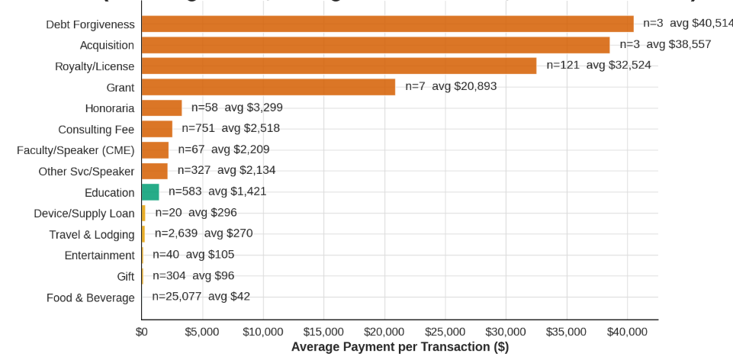
Figure 1: Average Payment per Transaction by Payment Type
Subsequently, we applied fraud transaction research techniques to the product and manufacturer text fields — tokenizing product names, mapping manufacturer-product dollar flows, and identifying bundling patterns. The results of this analysis are visualized in the bar chart below whereby it is clear that “surgical” is the most frequently used term within descriptive text fields from the Open Payments dataset.
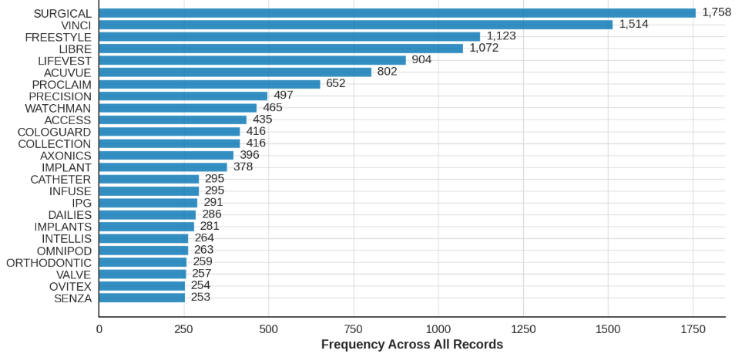
Figure 2: Top 30 Most Frequently Occurring Product/Device Terms
Following this analysis, we explored which manufacturers had the greatest amount of changed payment records by dollar value. This investigation was relevant to our research because changed/new records have a higher risk of association with fraudulent conduct than unchanged records. The bar chart below displays the top manufacturers with modified Open Payments records amounting to a total of $87,174.
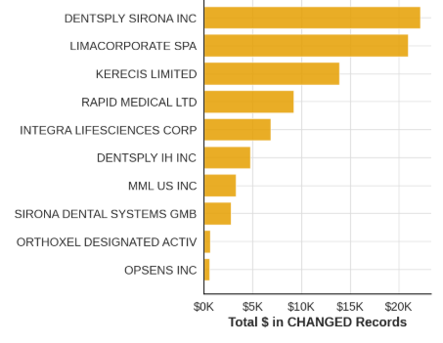
Figure 3: Top 10 Companies by Total Dollar Value in Changed Records
We then asked which DME categories where most closely associated with the manufacturers with modified payment records. The charts below demonstrate the prevalence of changed records by total dollar value for manufacturers associated with the specified DME category and the average transaction amount pertaining to said DME category.
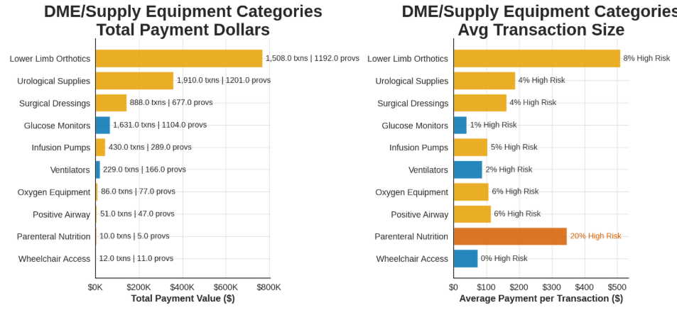
Figure 4: DME/Supply Equipment Categories - Total Payment Value and Average Payment per Transaction
Finally, we limited this analysis to the state of Missouri finding that providers associated with urological supplies accounted for the greatest dollar amount of changed Open Payments transactions with Medtronic Inc. particularly accounting for $96,648 of changed Open Payments records associated with urological supplies.
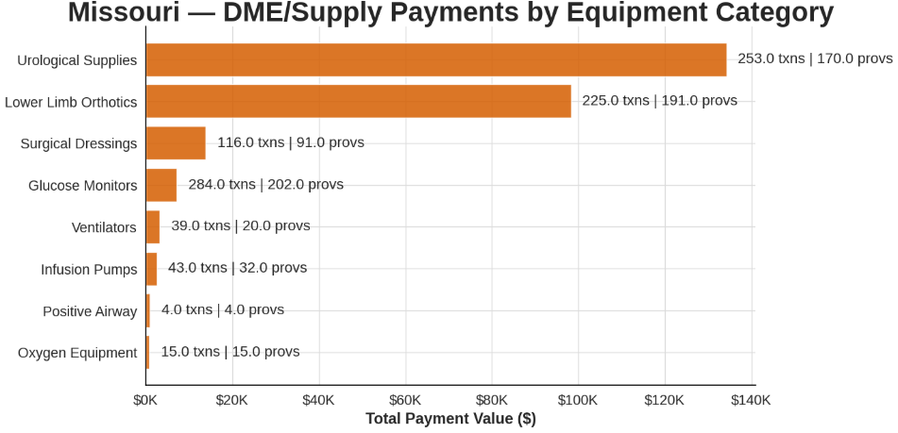
Figure 5: DME/Supply Payments by Equipment Category - Missouri

Manufacturer Payments and Referring Provider Reimbursements
We then analyzed the bivariate relationship of manufacturer payments to DMEPOS claims payments for providers who were covered recipients within each relevant specialty. To begin with we compared median Medicare DMEPOS claims reimbursement amounts received by providers receiving manufacturer payments to providers without manufacturer payments within relevant specialties.
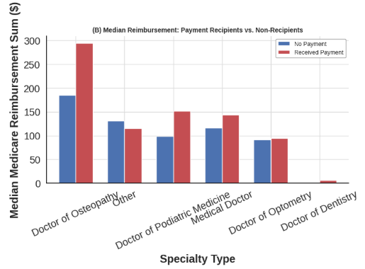
Figure 6: Median Medicare Reimbursement by Specialty Type
We then computed Spearman correlations of manufacturer payments to DMEPOS claims reimbursement totals within relevant specialties. The bar chart below displays the top 10 specialties with the greatest correlation values.
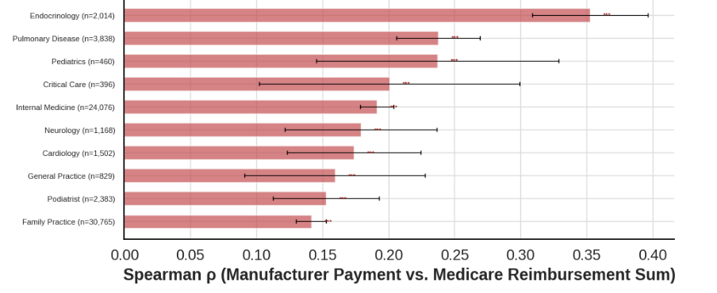
Figure 7: Spearman Correlation Between Manufacturer Payments and Medicare Reimbursement by Specialty
We also compare the Spearman correlation of manufacturer payments with total Medicare DMEPOS reimbursements to the Spearman correlation of manufacturer payments with total Medicare DMEPOS claims notably finding that the direction of the correlations reverses for the specialties Optometry, Podiatrist, and Interventional Pain Management.
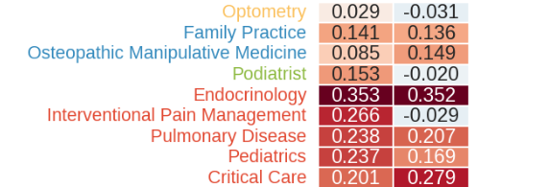
Figure 8: Spearman Correlation Between Manufacturer Payments and DMEPOS Reimbursements by Total Dollar Amount and Total Claims, Among Top Specialties
Across all specialties we observed a Spearman ρ of 0.0784 for total_payment vs avg_suplr_mdcr_pymt_amt_sum via bootstrap calculation. We observed a Bootstrap 95% Confidence Interval Standard Error of 0.0028. The results of our computation are plotted on the histogram below.
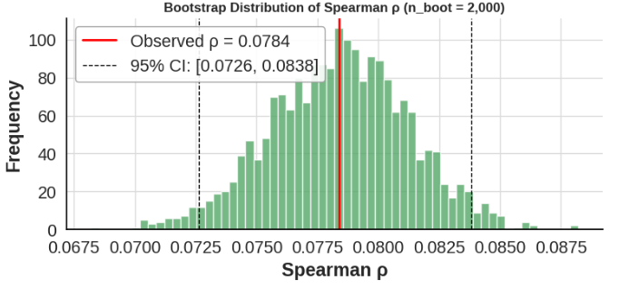
Figure 9: Bootstrap Distribution of Spearman Correlation Between Total Manufacturer Payments and Average Medicare Reimbursement

Unified Dataset
Our exploratory analysis of the unified dataset centered primarily upon whether features in the dataset could be reduced and if there were natural clusters apparent in the data. For feature reduction, we looked into the presence of multicollinearity by constructing a correlation heatmap to identify highly correlated features. We found for instance a very high correlation between the features first_payment_date and last_payment_date indicating that the inclusion of both within the final model may be inappropriate.
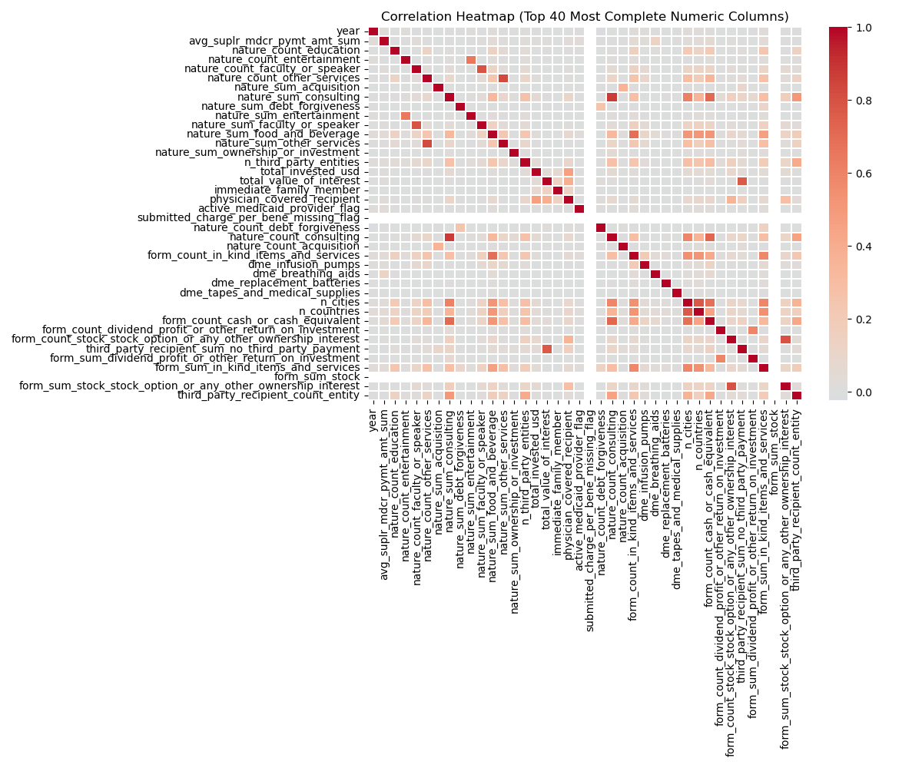
Figure 10: Correlation Heatmap of Top 40 Most Complete Numeric Features
Subsequently, by t-SNE clustering depicted in the following figure we determined appropriate reduction of the majority class for addressing the issue of class imbalance in our data.
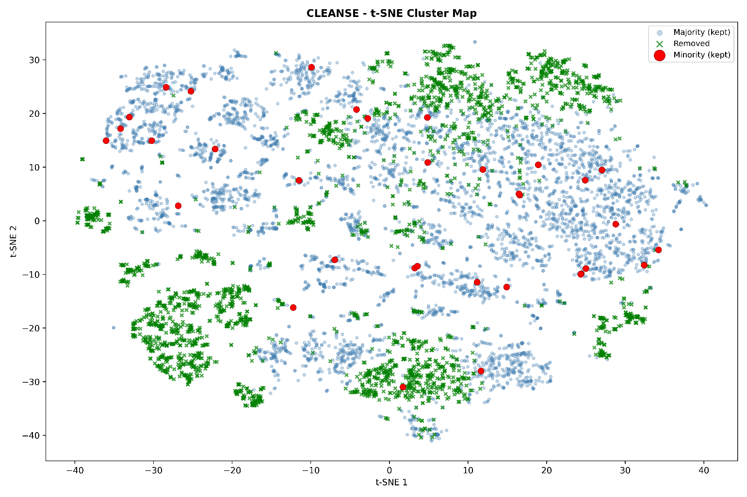
Figure 11: t-SNE Visualization of CLEANSE Undersampling

Statistical and Machine Learning Model Planning, Building, and Testing

Research and Analytical Plan
This section describes the step-by-step analytical methodology and reasoning behind each decision made in this project. The plan went through multiple iterations as the team read additional literature, met with subject matter experts, and encountered practical constraints in the data. What follows documents both the final pipeline and the pivots that shaped it.

Analytical Flowchart
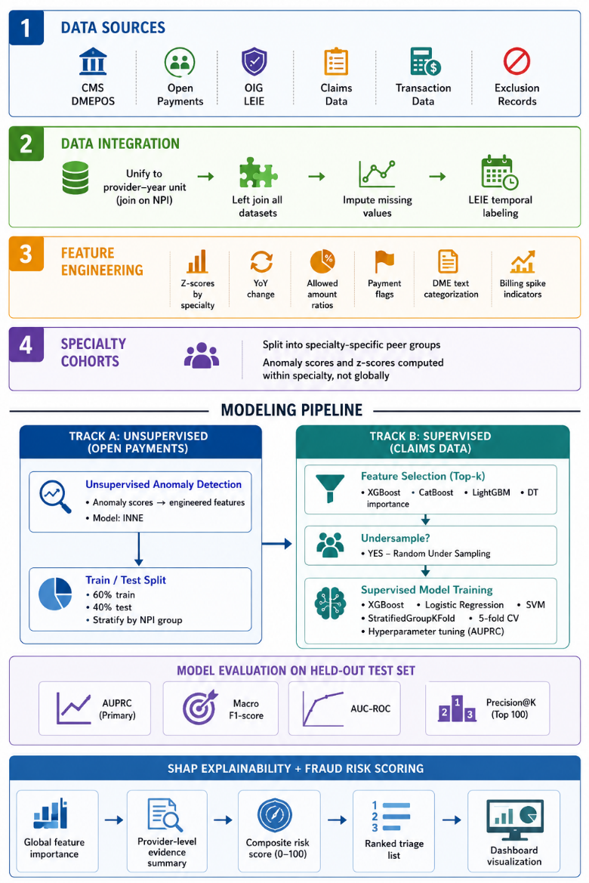
Figure 12: Analytic FlowChart
Image generated using ChatGPT (OpenAI).

Step 1: Data Integration and Unit of Analysis
The first decision was to establish a consistent unit of analysis across all datasets. CMS Medicare DMEPOS claims data, Open Payments manufacturer-to-provider financial transactions, and the OIG LEIE exclusion list each arrive at different levels of granularity. To make these joinable and comparable, all datasets were aggregated or left-joined to a common provider–year unit using the National Provider Identifier (NPI) as the linking key. This choice was essential because fraud labels from the LEIE are issued at the provider level, meaning any finer granularity would require assumptions about which specific claims were fraudulent. Our stakeholders' investigative workflow also operates at the provider level, meaning provider-level risk scores are the actionable output they can use. Within this unified framework, two model-ready datasets were maintained in parallel: a referring provider dataset derived from CMS DMEPOS referring provider records, and a billing supplier dataset derived from DMEPOS supplier utilization records. Keeping them separate allowed for more comparable peer baselines and specialty-specific anomaly detection within each group.

Step 2: Feature Engineering
Feature engineering was performed to transform raw billing and financial records into variables that capture known fraud patterns. Several categories of features were constructed. Temporal features included year-over-year changes in claim volume and allowed amounts. Billing deviation features included z-scores for allowed amounts, claim counts, and service frequencies computed within specialty groups, as well as ratios of a provider's allowed amounts to national averages for the same HCPCS code capturing providers billing at rates significantly above or below peers, a pattern associated with upcoding and phantom billing. For the Open Payments dataset, AI-assisted text normalization was used to categorize payment records into DME product families, enabling structured features from otherwise unstructured fields. Payment type flags were also constructed to identify categories that domain experts identified as worth further investigative attention.

Step 3: Specialty-Specific Cohort Creation
A key decision was constructing specialty-specific cohorts rather than treating all providers as a single population. Billing behavior varies substantially across specialties, for instance a neurologist's claim volume and allowed amounts are structurally different from those of an ophthalmologist meaning flagging anomalies relative to the entire provider population produces noisy, misleading results. By grouping providers into specialty subsets, z-scores and anomaly scores reflect deviation from a meaningful peer group. This decision was directly informed by the literature, and our feature engineering accordingly computes z-scores within specialty groups rather than globally.

Step 4: Labeling
Providers were labeled as fraudulent or non-fraudulent by joining the unified provider-year dataset to the OIG LEIE exclusion list via NPI. To prevent data leakage, a provider was only assigned a fraud label in a given program year if their LEIE exclusion date fell within or after that year, ensuring the model was never trained on behavior already known to be fraudulent at time of record. This approach follows the methodology established by in prior work [38]. It is important to acknowledge that the LEIE captures only providers who were formally prosecuted and excluded, meaning many truly fraudulent providers remain unlabeled in the non-fraud class. The true fraud rate is therefore almost certainly higher than the labels suggest, and the class imbalance is likely more severe than the data alone indicates.

Step 5: Class Imbalance and Sampling Design
Across all geographic subsets of the data, confirmed fraud labels represented less than 0.15% of provider-year records, making this an extreme rare-event classification problem. Standard accuracy metrics are meaningless under such conditions. This reality drove all downstream decisions about sampling and evaluation. Random under sampling was selected as the primary strategy, and the team explored a range of class ratios from 99.9:0.1 to 50:50. Cluster-based under sampling using CLEANSE was also evaluated but consistently underperformed compared to random under sampling across iterations and was not included in the final configuration The final pipeline compared configurations both with and without under sampling. As documented in the model evaluation section, random under sampling was selected as the optimal strategy for the final configuration.

Step 6: Track A (Unsupervised Anomaly Detection)
Alongside the supervised pipeline, unsupervised anomaly detection was conducted on the Open Payments dataset to identify statistically atypical financial relationships between manufacturers and providers. The Isolation using Nearest Neighbor Ensemble (INNE) model was selected for this stage, chosen for its demonstrated effectiveness in payment anomaly detection literature and its computational efficiency on large datasets. INNE achieved an AUPRC of 0.0012 more than double the adjusted lift of the alternative models evaluated. Following model selection, INNE scores were aggregated from the transaction level to the NPI-year level, yielding three engineered features: inne_score_mean, capturing a provider's typical level of payment irregularity across a given year; inne_n_above_p95, the count of transactions exceeding the 95th percentile anomaly threshold; and inne_pct_flagged, the proportion of transactions surpassing that threshold. These features were incorporated into the supervised pipeline as additional predictor variables to test whether anomaly signals from manufacturer payment data could improve fraud classification. Ultimately, their inclusion did not improve cross-validation performance and was therefore excluded from the final model configuration, suggesting that the claims-based features alone captured sufficient discriminative signal for the supervised stage. A finding that suggests the claims-based features alone captured sufficient discriminative signal for the supervised stage.

Step 7: Track B: Train/Test Split and Feature Selection
The claims data was split into a 60% training set and 40% test set using stratified sampling to preserve the fraud class ratio across both partitions. The split was performed at the NPI level using group constraints, meaning all records belonging to a given provider appeared exclusively in either the training set or the test set, eliminating the risk of data leakage across provider-years. Feature selection was then performed using built-in importance metrics from three tree-based classifiers: XGBoost, CatBoost, and Decision Tree. Rather than relying on a single ranker, SelectKBest was applied across these independent importance rankings, and model performance was compared across varying values of k to identify the feature count that maximized AUPRC on the validation folds. The final best-performing configuration used 100 selected features.

Step 8: Cross-Validation and Hyperparameter Tuning
Cross-validation during hyperparameter tuning used StratifiedGroupKFold with 5 folds, simultaneously maintaining class balance within each fold and enforcing NPI-level group separation. Tuning began with a minimal parameter grid to establish a low-cost baseline, then expanded iteratively, stopping when additional grid expansion no longer produced meaningful improvements in AUPRC. Fold stability was assessed by examining the standard deviation of AUPRC scores across folds, a low standard deviation indicated performance was driven by the hyperparameters rather than by which providers happened to fall in each fold.

Step 9: Supervised Model Training and Evaluation
Three supervised models were trained and evaluated: XGBoost, Logistic Regression, and SVM. XGBoost was selected for its well-documented strength on tabular, class-imbalanced data and its native compatibility with SHAP-based interpretability, making it well suited to both detection performance and investigator-facing explainability. Logistic Regression served as a transparent baseline, producing calibrated probability scores that can be communicated directly to non-technical stakeholders without requiring knowledge of the underlying model mechanics. SVM was included given its established presence in the healthcare fraud detection literature, providing a useful point of comparison against the tree-based approach. All three models were evaluated on the held out 40% test set, with AUPRC serving as the primary metric. AUPRC was prioritized over AUC-ROC because under extreme class imbalance, AUC-ROC can remain artificially high even when a model performs poorly on the minority class, the fraud class, whereas AUPRC directly measures performance where it matters most: precision and recall among flagged cases. Secondary metrics reported include Macro F1, AUC-ROC, Macro Precision, Macro Recall, and Precision@K, where K equals the top 100 flagged providers. Precision@K was included specifically because our stakeholders operate under fixed investigative capacity a ranked list where a meaningful share of the top-flagged providers is confirmed fraud cases delivers more operational value than any aggregate curve statistic alone.

Step 10: Explainability and Risk Scoring
SHAP values were computed for the final supervised models to produce both global feature importance rankings and provider-level explanations. At the global level, SHAP identifies which billing and payment features most consistently differentiate fraud from non-fraud across the full dataset. At the provider level, SHAP produces a ranked list of the specific features driving each provider's score enabling an investigator to understand not just that a provider was flagged, but precisely which behaviors triggered the flag. Each provider ultimately receives a composite fraud risk score aggregated across model outputs, scaled to a consistent range, and paired with a top-contributing-factor summary. This score feeds directly into the dashboard triage interface, where investigators can sort providers by risk level, drill into individual evidence summaries, and cross-reference findings with OIG records via the AI assistant.
Result evaluation is more challenging in this project because unsupervised, explainable machine learning is inherently difficult to validate, particularly with respect to quantifying false positives. In the beginning, we planned to rely exclusively on supervised learning approaches since that is the primary methodology used in fraud detection and other similar works. However, as the project evolved, we explored positive–unlabeled (PU) learning as an alternative, but this direction was not supported by our stakeholders or industry subject-matter experts. Industry experts primarily deploy unsupervised models, so we have chosen that direction. We also considered incorporating a geospatial component at one stage, yet stakeholders ultimately did not view this perspective as sufficiently useful for the project’s objectives.
For an initial test of supervised machine learning, we attempted to implement the extreme gradient boosting algorithm for decision trees in a similar manner to Johnson & Khoshgoftaar [38]. We modified to an 80%-20% train-test split compared to their five-fold cross validation and applied the same hyperparameters to the model. This model failed to predict any fraud in testing. One benefit of applying this technique was that we received feature importance scores in the form of information gain. By iterating on a subset of important features, the team was able to recover a more useful model through the feature selection process described above. Oversampling and under sampling were both subsequently considered, with random under sampling ultimately selected as the primary strategy.

Statistical and Machine Learning Model Validation, Visualization, and Interpretation

Final Model Selection and Evaluation

Project goal and how it links to the model outcomes:
The central research question of this capstone was: How well can machine learning detect healthcare fraud risk from public data, and can the integration of anomaly detection approaches improve current methods?
To address these questions, we have gotten valuable guidance and feedback from two primary stakeholders: the Missouri Medicaid Audit and Compliance (MMAC) and the Missouri Fraud Control Unit (MFCU). Both agencies heavily rely on human referrals, federal networks, and purchased software to produce investigative cases. Their core challenge is that of scale - the provider population being too large for manual review, flagged cases turning out to be legitimate, and limited investigative resources being funneled towards high-dollar or legally straightforward cases, leaving more nuanced signals being unexamined.
The system developed in this capstone project addresses these limitations while keeping the investigators and their judgments at the center of the process. By generating a manageable, prioritized list of high-risk providers, with transparent and citable evidence in the form of contributing features, the system gives the investigators a data-driven starting point, which allows them to focus their resources on cases that are most likely to warrant further review.
Given the extreme class imbalance in the data, traditional classification accuracy is not a meaningful measure, as a model that flags no one as fraudulent would still achieve a high accuracy. Therefore, the project prioritizes AUPRC, Macro Precision, and Precision@K as the primary evaluation metrics.

Class Imbalance Challenge
Before covering the model results, it is important to establish the scale of the challenge. The below table summarizes the prevalence of fraud across different geographical subsets of the data. It shows that the true fraud labels represent less than 0.15% of any subset, confirming that fraud is an extremely rare event and that even detecting a small number of confirmed cases is a meaningful outcome.

Subset | Fraud Provider-Year Services | Total Provider-Year Services | Fraud % | Fraud Provider-Years | Total Provider-Years | Fraud %
Missouri | 47 | 110,181 | 0.1334% | 23 | 23,649 | 0.0973%
MO + Bordering States | 543 | 817,496 | 0.0664% | 72 | 179,322 | 0.0402%
Full Dataset | 1629 | 4,413,118 | 0.0369% | 321 | 1,157,253 | 0.0277%
Table 4: Fraud Prevalence by Geographic Subset
It is also worth mentioning that both MMAC and MFCU have emphasized that capturing all the fraud is neither a realistic nor expected goal. Fraud is inherently difficult to confirm, evidence is often incomplete, and many cases that initially appear suspicious are more often than not found to be legitimate. Therefore, capturing even a handful of confirmed cases from millions of records can be considered a significant operational win, as each confirmed case represents a direct benefit to the public by protecting Medicare/Medicaid funds and vulnerable beneficiaries.

Final Model Configuration
After continuous and iterative experimentation across multiple models, undersampling strategies, and feature selection methods, all of which have been documented and discussed in the preceding section, the final model configuration selected was:
Component | Selection
Model | XGBoost
Feature Selection | SelectKBest LightGBM
Undersampling | Random Undersampling
Anomaly Detection | None
Table 5: Final Model Configuration
The integration of INNE-derived anomaly detection features into the supervised pipeline did not yield any improvements in cross-validation scores and was therefore not included in the final configuration.
Through multiple iterations, cluster-based undersampling consistently underperformed when compared to random undersampling, resulting in significant performance dips. Therefore, random undersampling was considered to be the ideal choice.

Unsupervised Model - Anomaly Detection
Prior to the supervised pipeline, an unsupervised anomaly detection stage was conducted on a custom feature engineered CMS Open Payments (General Payments) dataset. Three models were evaluated: Empirical Cumulative Distribution-based Outlier Detection (ECOD), Isolation Forest, and Isolation using Nearest Neighbor Ensemble (INNE).
These three models were chosen for their algorithmic diversity, their demonstrated use in health fraud and payment anomaly detection literature and for their computational efficiency on large datasets. The performance of each model was evaluated using AUPRC as the primary metric, along with the Mann-Whitney test to assess whether anomaly scores were higher for known fraud providers than legitimate providers. The dataset used was split into a train-test split, with all metrics evaluated on the test set.
Isolation forest and INNE were tested across multiple parameter combinations and varying top feature counts to identify the best combinations. ECOD on the other hand was a deterministic approach and as such, required no hyperparameter tuning.
Model | AUPRC | Baseline AUPRC | Adjusted AUPRC | Mann-Whitney U | Mann-Whitney p
ECOD | 0.0007 | 0.0005 | 0.0002 | 43995093 | 2.937E-10
Isolation Forest | 0.0008 | 0.0005 | 0.0003 | 45850325 | 4.544E-14
INNE | 0.0012 | 0.0005 | 0.0007 | 50359065.5 | 3.681E-26
Table 6: Unsupervised Model Comparison
INNE outperforms the alternative models across every metric, achieving the highest AUPRC score of 0.0012. Its adjusted AUPRC score, representing the lift above the baseline was more than double that of ECOD and Isolation Forest, and also demonstrated significant statistical separation between fraud and non-fraud anomaly scores. All three models produced statistically significant results, highlighting that each approach was capturing actual signals rather than noise, but INNE’s consistency across every metric made it the clear choice.
Parameter | Value
Top K features | 15
contamination | 0.0005
max_samples | 8
n_estimators | 100
Table 7: Best Parameters - INNE
Diving deeper into INNE’s performance, the below figure shows the distribution of anomaly scores by label. Fraud providers tend to score higher than those considered legitimate, which indicates INNE can meaningfully separate the groups with the signals it captures. However, there are providers with very low scores - acting as outliers – highlighting the inherent difficulties in identifying fraud.
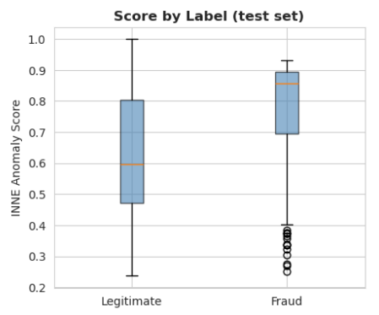
Figure 13: Score by Label - INNE
Following the model selection, INNE scores were aggregated from the transaction level to the NPI-year level to create a rollup table. From this table, three features were extracted and joined into the main supervised modeling dataset - if and when anomaly detection is to be used - as additional predictor variables.
- inne_score_mean: The average INNE anomaly score across all the transactions of a provider at a given year to capture their typical level of payment irregularity
- inne_n_above_p95: The count of transactions scoring above or at the 95th percentile anomaly threshold
- inne_pct_flagged: The percentage of transactions that exceeded the 95th percentile threshold
These three features add additional context on anomalies in manufacturer payments, dimensions that are absent from the referral provider dataset used by the supervised model. A provider may bill within normal ranges in the CMS claims data while simultaneously receiving unusually structured payments from manufacturers, a pattern that would not be detected by the supervised model alone. By combining these two datasets, the INNE-derived features should, on paper, strengthen the supervised model with additional fraud signals. However, as noted in the previous subsection, their inclusion did not yield improvements in performance and as a result, were excluded from the final model configuration.

Supervised Model Performance
XGBoost model was tuned across multiple runs with progressively refined hyperparameter grids using Stratified Group K-Fold cross-validation (5 folds and grouped by NPI) with AUPRC as the scoring metric. The table below summarizes some of the notable runs and their respective results and configurations.
Runs | Features (k) | Best CV Score | Std Across Folds | Feature Selection | Undersampling | Best parameters
Attempt 1 | 10 | 0.2399 | ± 0.1860 | K-best XGB | RandomUnderSampler | learning_rate: 0.01  max_delta_step: 5  min_child_weight: 1  n_estimators: 300  scale_pos_weight: 50
Attempt 10 | 20 | 0.0295 | ± 0.0573 | K-best XGB | CLEANSE | colsample_bytree: 0.8  reg_alpha: 0.1  reg_lambda: 1  subsample: 0.6
Attempt 14 | 20 | 0.2726 | ± 0.1631 | K-best XGB | RandomUnderSampler | learning_rate: 0.05  max_delta_step: 5  min_child_weight: 5  n_estimators: 350  scale_pos_weight: 50
Attempt 16  (With INNE) | 20 | 0.2566 | ± 0.1659 | K-best XGB | RandomUnderSampler | colsample_bytree: 1  reg_alpha: 0  reg_lambda: 1  subsample: 1
Final Attempt  (Selected Configuration) | 100 | 0.2385 | ± 0.1492 | K-best LightGBM | RandomUnderSampler | colsample_bytree: 0.6  gamma: 20  max_depth: 4  min_child_weight: 3  subsample: 0.9
Table 8: XGBoost Cross-Validation Results on Training Data
While attempt 14 produced the highest CV AUPRC of 0.2726, the final configuration was selected based on consistency and stability rather than peak performance. The standard deviation across folds decreased progressively from ± 0.1860 in the initial few runs, all the way down to ±0.1492 in the final run.
The high standard deviation observed across all runs reflects label sparsity, as confirmed fraud labels constitute an extremely small proportion of the overall dataset, even small differences in fold composition have an exaggerated effect on performance. The final configuration was selected on the basis of stability over raw score, as a lower standard deviation indicates more consistent and reliable generalization across different subsets, making it a more dependable choice as an operational investigative tool.
Model Comparisons and Selection Rationale:
Logistic regression was used as a baseline and actually performed quite well on training data across multiple varying configurations, some of which achieved a high CV AUPRC score, the highest being 0.4438, which was higher than XGBoost on paper. However, such configurations were accompanied by extremely high standard deviations, the largest of all the models evaluated, indicating severe instability across folds.
SVM was also evaluated. Focusing on a polynomial kernel, multiple configurations were tested. While the CV scores were competitive, the model proved impractical on the test set.
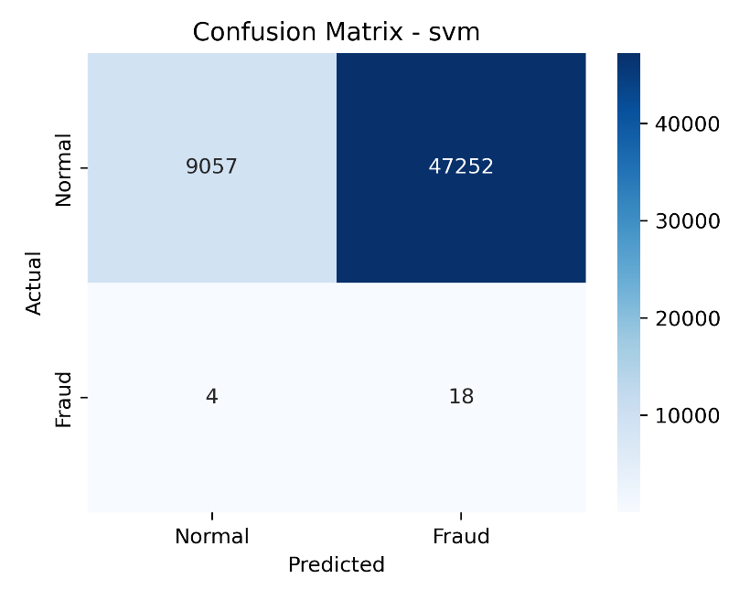
Figure 14: SVM - Confusion Matrix
The figure above shows that the model flagged approximately 84% of all normal providers as fraudulent, while correctly identifying 18 of 22 actual fraud cases. Even though recall was strong, the model was extremely biased toward the positive class, resulting in an overwhelming volume of false positives, making the model unsuitable for operational use. Therefore, XGBoost was selected as the final model, as it offered a more balanced and operationally viable tradeoff between capturing fraud cases and limiting false alarms.
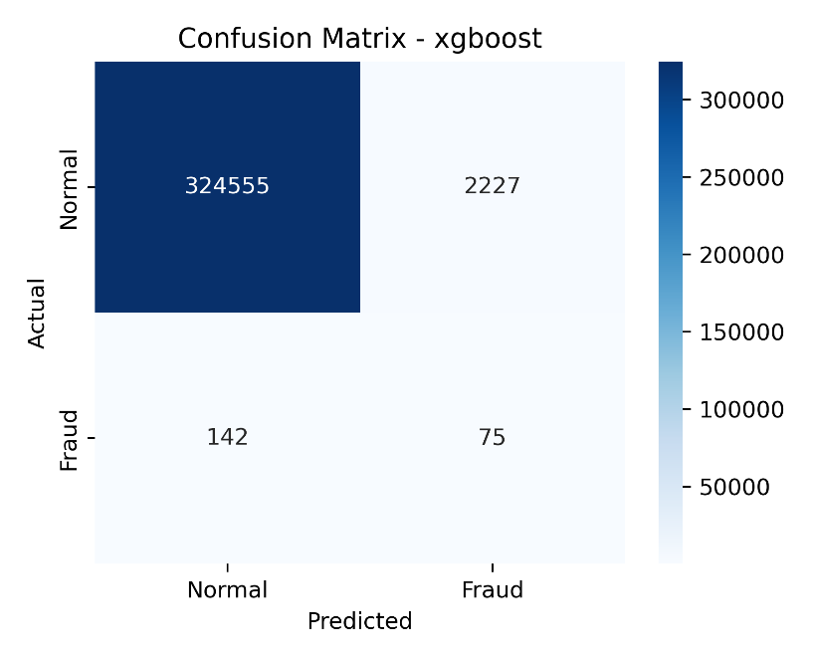
Figure 15: XGBoost - Confusion Matrix
The above figure shows the XGBoost confusion matrix on the test set, showcasing its ability to classify provider but also highlighting the recall-biased behavior.
Bias and Accuracy Interpretation:
The following table lists the test set metrics from the final model.
Metric | Score
Macro F1 | 0.5280
Macro Precision | 0.5161
Macro Recall | 0.6694
AUPRC | 0.0331
AUC-ROC | 0.8818
Table 9: Test Set Metrics from Final Model
The stakeholders did express a preference for precision, as they do not want to be overwhelmed with false alarms. However, given the extreme class imbalance, the model naturally leans toward recall. The Random Undersampling strategy rebalances the training data by reducing the majority class, which limits the information available about normal providers, while also exposing the model to a seemingly higher proportion of the fraud cases during training, making it more sensitive to the minority class.
The AUPRC of 0.0331, while low in absolute terms, reflects the difficulty of the problem given the extreme class imbalance and its handling. The macro F1 score of 0.5280, while acceptable, showcases the expected tradeoff between precision and recall across both classes.
Even though an AUC-ROC score of 0.8818 was recorded, it is not the primary measure as it is heavily influenced by the majority class under extreme class imbalance, making it an unreliable indicator of performance. In practice, the most meaningful measure for this system is Precision@K, where at the top of the risk-ranked output, 1 in 5 of the top 20 flagged providers were confirmed to be fraudulent.
Operational Performance - Precision@K:
Precision@K answers the most relevant operational question: of the top K providers ranked by predicted fraud probability, how many of them are actually fraudulent?
This was answered by having the model assign a predicted fraud probability to each provider, which were then ranked in descending order to identify the highest risk cases.
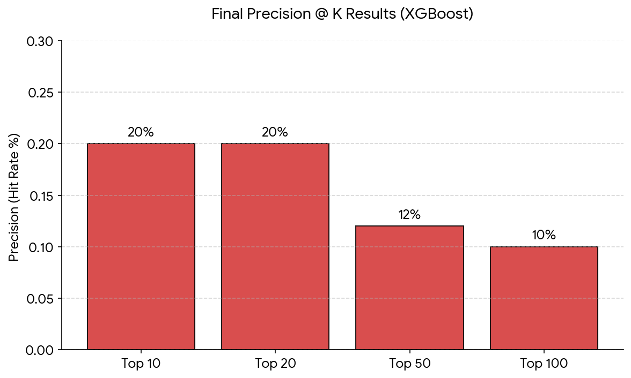
Figure 16: Precision@K
A consistent 20% hit rate across the top 20 providers, declining to 10% at the top 100, is an impressive result given that only 217 out of 326,999 provider-year records are confirmed fraud cases, giving a fraud prevalence baseline AUPRC score of approximately 0.00066. The model's ability to identify 10 confirmed cases in the top 100 alone represents a 50x lift over that baseline, confirming that it is successfully concentrating known fraud at the top of its output.
Interpretability and Risk Stratification:
Understanding which features drive the risk score is essential for making outputs explainable and traceable. From the final supervised model, SHAP values were computed on the test set to identify the features that influenced individual predictions. The below figure shows the top 10 features by mean absolute SHAP value. The single most dominant predictor was “Services per beneficiary” followed by “Third party recipient sum”. An unexpected finding was the missing data flags, specifically “Claims per beneficiary” and “Submitted Charges per Beneficiary” among the top 10 features. This suggests that the pattern of missing data itself carries some predictive power, where providers with systematically absent fields could reflect irregular claims billing behavior, a very nuanced finding that could warrant further investigation.
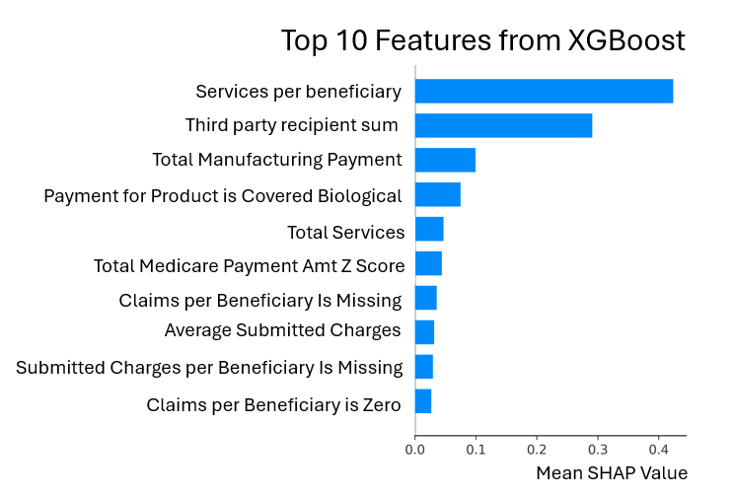
Figure 5: XGBoost - Feature Importance
To add on to explainability, the model’s predicted probabilities were transformed into risk tiers. By stratifying the provider population into prioritized groups, investigators are informed of the providers that require immediate attention, while also reducing the exhaustion of resources.
Tier | Percentile
Low | Below 50th percentile
Medium | 50th – 90th percentile
High | 90th – 95th percentile
Critical | Above 95th percentile
Table 10: Tier Percentiles
The risk tiers were defined by percentile-based cutoffs of the predicted probability scores on the test set as shown in the above table.
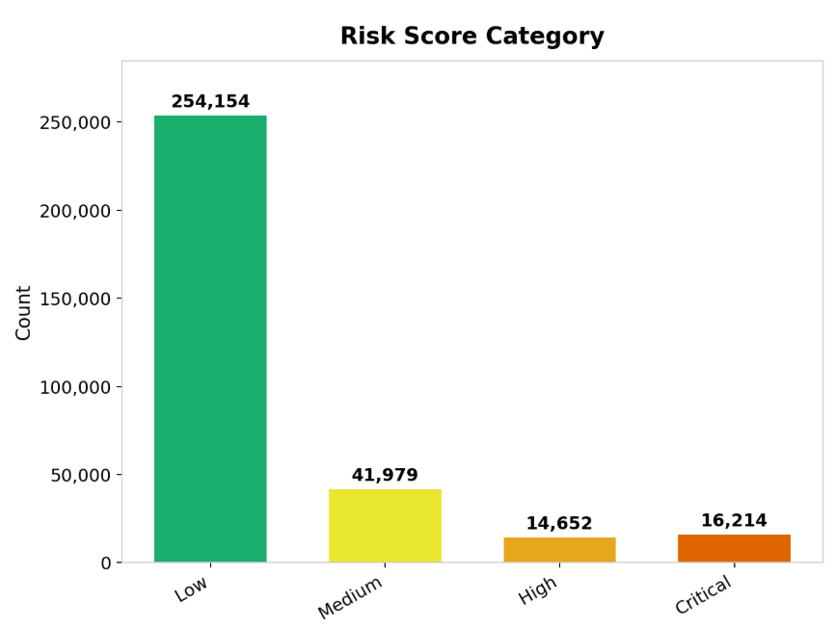
Figure 6: Risk Score Category
The vast majority fall in the Low and Medium tiers, while a much smaller proportion are classified as High or Critical. The Critical tier in particular represents a highly condensed shortlist of high-risk providers, drastically reducing the number of cases investigators need to review while still capturing actual fraud cases. This is further supported by the Precision@K results: of the top 100 providers, all of which fall within the Critical tier, 10 were confirmed fraud cases, confirming that the stratification is extremely useful and can help investigators prioritize effectively.

Machine Learning Pipeline - Conclusion
The results of this capstone project confirm that machine learning can detect healthcare fraud risk from publicly available data. The final model delivered a 50x lift over the fraud prevalence baseline and maintained a 10% confirmed fraud hit rate among the top 100 flagged providers. While the unsupervised anomaly detection did not improve any of the approaches when integrated, it did identify INNE as the best performing model and provided valuable context on manufacturer payment anomalies. It is from these results that both research questions have been answered.
As mentioned earlier, both MMAC and MFCU have acknowledged that capturing all fraud is neither realistic nor expected. Therefore, the value of the project lies in the system’s ability to narrow down an unmanageable pool of providers into a prioritized shortlist that is backed by evidence, in turn, providing the investigators with a credible starting point that previously did not exist.

Evaluation of the AI Assistant
As part of the final deliverable, an agentic AI system was developed and integrated into the investigative dashboard. To assess its usability, a structured Usability Score Template was created.
This section will layout the usability dimensions for the AI assistant tool, measuring how easily and effectively users can accomplish their tasks while using it.
AI Assistant pipeline:
- Question Interpretation: Based on what the user asks, the LLM will decide which website to search.
- Tool routing based on decision: The LLM chooses the following
  - OIG tool or
  - SOS tool or
  - Fallback (recommends specifying the other site )
- Information Retrieval via Web scraping (Using Selenium):
  - MCP tool used to scrape specific site
  - Returns contents in structured manner specified in the code
- Synthesis of information by the LLM:
  - Provides a quick summary
  - Provides its own analysis
  - Returns a link to the original report or record
- Failure Mode: If the wrong site was scraped, the system will recommend the user to re-issue the query with the other website/websites specified.
Based on the above pipeline, the scoring will be designed around 5 core pillars and are as follows:
- Task success Score (TSS), 25%
  - Measures whether the user can complete their task using the AI assistant instead of manually searching.
  - How will it be measured:
    - Did the user get an answer in a single interaction?
    - Was multiple interactions needed?
- Formula: Based on the number of interactions
Interactions Required | Score
1 | 100
2 | 90
3 | 80
4 | 75
5 | 70
6+ | 10-65 (Scorer’s discretion)
No information available | 50 - Neutral

- Routing Accuracy Score (RAS), 25%
- Measures whether Gemini picked the correct source on the first try.
- Formula:
Outcome | Score
Correct source selected on first try | 100
Incorrect source selected, corrected on retry | 50
Incorrect source selected, not corrected | 0
No information available | 50 - Neutral

For this measure, we only look at the source the AI uses, not the content.

- Retrieval Efficiency Score (RES), 20%
  - Condition: Specific to MCP tool performance. Must be tested independently of the LLM by running it directly and comparing output against the official report/record.
  - Measure: Result must be compared with information on official report/record:
Outcome | Score
Full Retrieval with correct structure | 100
Full Retrieval, minor missing fields or structure issues | 80
Partial Retrieval, major missing fields or structure issues | 40-60
Site accessible, but minimal data pulled | 5-30
Site unreachable or tool crashed | 0
No information available | 50 - Neutral

- Information Quality Score (IQS), 20%
  - Measures the clarity, completeness and relevance of the LLM response.
  - Measure: Scored across four dimensions, then averaged. If N/A then ignore.
Dimension | Description | Score
Correctness | Is the information factually accurate vs the official record? | 0-100
Completeness | Does the response cover all relevant fields from the record? | 0-100
Relevance | Was the response focused and free of out-of-scope information? | 0-100
Source | Was the response derived from OIG/SOS data? Link provided ? | 0-100

IQS = (Correctness + Completeness + Relevance + Source) / 4
Ignore N/A dimensions and adjust the denominator accordingly.

- Fallback Score (FS), 10%
  - Captures the AI assistant behavior when no information was available on any of the available websites.
  - Measure: Starts off with 100 points, deduct penalties as applicable.
  - Penalties:
Outcome | Score
Does not recommend user specify the other source | -20
Confidently states incorrect information instead of admitting no result | -20
Does not provide any next steps | -20
Returns a broken or incorrect source link | -20
Hallucinates a record that doesn't exist | -20

Overall score calculated using the formula below:
Usability Score = 0.25(TSS) + 0.25(RAS) + 0.20(RES) + 0.20(IQS) + 0.10(FS)

Stakeholder Feedback
Both MMAC and MFCU were presented with a shortened and simplified version of the usability score template to evaluate whether the agentic AI assistant enhanced the current investigative process. The table below summarizes the scores and feedback received across four core criteria.
Criteria | MFCU Score (Feedback) | MMAC Score (Feedback)
Task automation | Score: 80  Would benefit from searching all available websites within a single query. | Score: 100  Really cool and answers the query provided.
Correctness | Score: N/A  No strict correctness | Score: N/A  Validation is handled by investigators, not by the current user.
Completeness | Score: 80  Subjective; depends on the number of follow-up questions. | Score: 80  Subjective; appreciated the inclusion of a link to the original report.
Relevance | Score: 80  Relevant; depends on the source selected by the AI if none were mentioned | Scores: 80  Relevant; would benefit from an expanded AI scope.
Table 11: Stakeholder Feedback
Overall, the AI assistant was well received by both stakeholders. Task automation scored the highest, which reflects the AI assistant’s ability to quickly and efficiently answer queries. However, the tool is far from perfect. The main area of improvement identified was the scope of the assistant - being able to search additional government sources, like the Department of Justice (DOJ) website and retrieving information from multiple sources in a single query. As for correctness, there was no strict correctness standard and as such, was not scored by either stakeholder.
That being said, both stakeholders found it useful, as it eliminated the need for manual searching and presented the information in an easy-to-read format with a source link to the original report. From this feedback, it can be concluded that the AI assistant did in fact enhance the investigative process.

Data Story / Product Development and Report Generation

Data Story

Background. Our project “Detecting Fraud Signals in Centers for Medicaid and Medicare Services (CMS) Data” focuses on the healthcare fraud, waste and abuse that drains billions of taxpayer dollars each year and undermine the integrity of federally funded programs. Bad actors are motivated by opportunity, rationalization, and financial pressure to use healthcare as a means for fraudulent activity.
One particularly vulnerable area involves Durable Medical Equipment, Prosthetics, Orthotics, and Supplies (DMEPOS) which includes items such as wheelchairs, prosthetics, and medical supplies. DMEPOS is a frequent target of fraud and has a high improper payment rate. In Fiscal Year (FY) 2024, CMS identified $1.9 billion (21.4%) in improper payments related to DMEPOS. CMS is taking significant actions to crush fraud conducted by DMEPOS suppliers. The traditional fraud detection system takes time and relies heavily on manual audits and retrospective reviews, which are often slow, resource-intensive, and reactive rather than preventive.
To assist with this problem, our approach…
…uses an analytical framework that integrates CMS DMEPOS claims, Open Payments, and the OIG Exclusion List into a standardized dataset. We apply an explainable hybrid model pipeline using Isolated Nearest Neighbor Ensemble and XGBoost to determine baseline “normal” behavior across our focused population, then flag providers who have a higher estimated likelihood of fraud risk without needing to utilize large numbers of confirmed fraud labels. For transparency, the score is paired with top contributing anomaly factors, enabling faster, more consistent investigative prioritization.
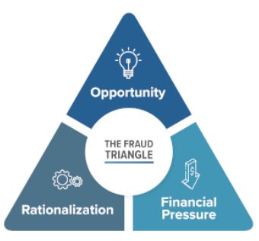
Fig 1. Fraud triangle. Source: Fraud Conference News.
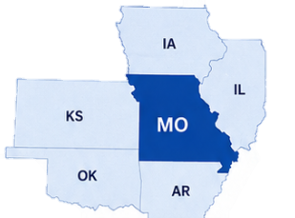
This project focuses on Missouri and bordering states, showing how public CMS data, machine learning, and AI assistants can help fraud investigators and analysts identify fraud signals in durable medical equipment (DME) data.

A New Dimension to DME Fraud Review.
Open Sunshine Payments are an untapped data source for fraud review. Advances in Artificial Intelligence (AI) allow for better categorization of free text product data.

Our project brings together data on key entities across the DME supply chain, including suppliers and providers who may receive incentive payments from manufacturers.

DME Product Incentive Payments to Providers
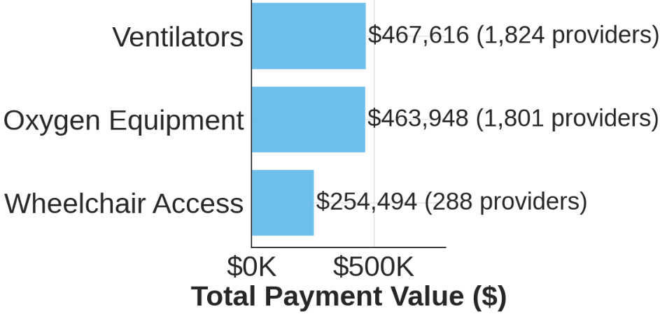
Fraud investigators can now monitor overall trends of incentive payments in high-risk DME products.
Identifying Supplier Billing Spikes. A sudden spike in billing, especially when supplier activity shifts from none to high volume and then back to none, is a common fraud scheme and suggests unusual behavior.
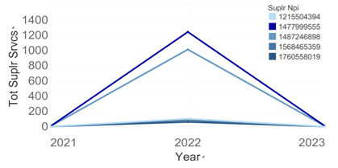
Top Specialties with Exclusions.
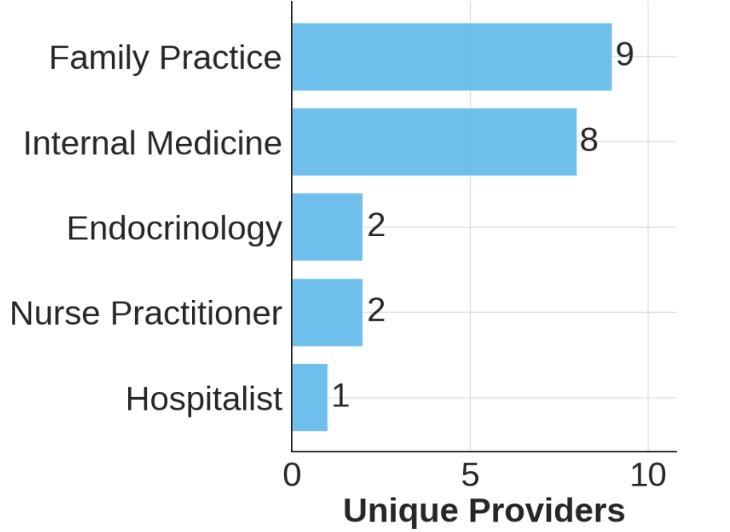
There are only a few providers with active exclusions in Missouri and bordering states. Family practice is the leading specialty with the most providers committing healthcare fraud.

The best model configuration. The highest performing model used random undersampling, a LightGBM-based feature selector, and an XGBoost classifier, while excluding payment anomaly detection priors. XGBoost, a common method in fraud detection, is a machine learning method that makes predictions by combining many small decision trees.
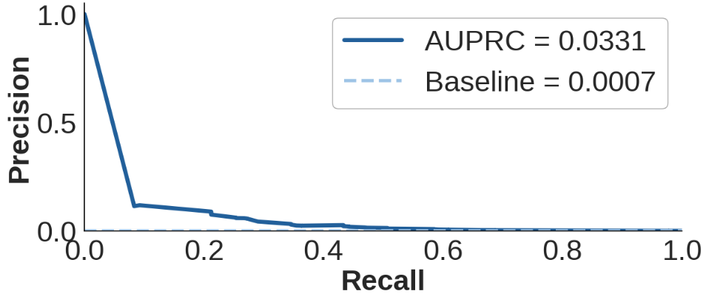
The model is 50 times more likely to flag a record that is fraud compared to baseline fraud prevalence.
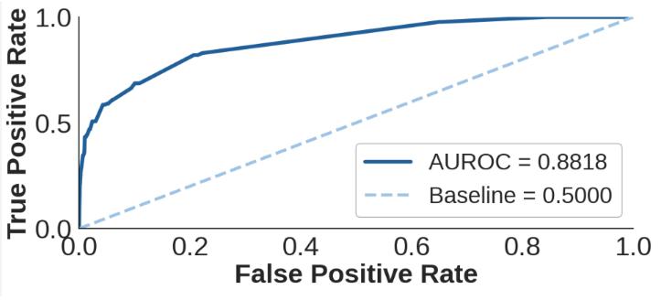
The AUROC is also much higher than the baseline. This graph suggests that the model can identify many fraudulent cases without flagging too many non-fraud cases.
Top Fraud Signals.
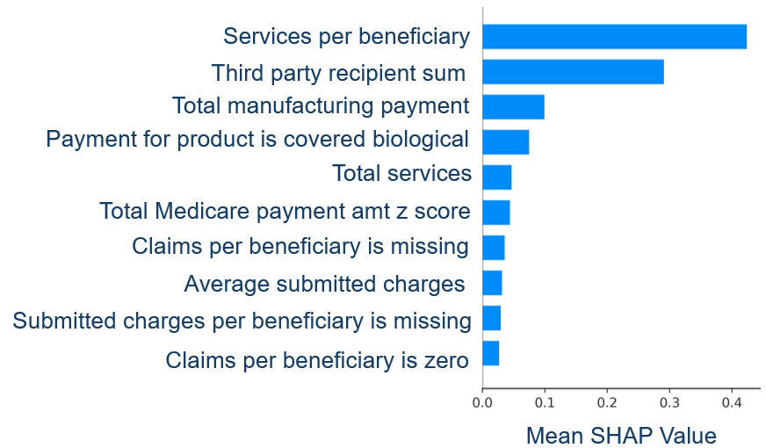
The higher number of services per beneficiary and whether they received manufacturing payments from a third party contributed the most information to a higher likelihood of fraud overall.

Using Agentic AI to Improve Investigation Efficiency. Our AI assistant uses a Model Context Protocol server to search authoritative sources and support transparency. Overall, the AI assistant was well received by both stakeholders. Task automation scored the highest, which reflects the AI assistant’s ability to answer queries quickly and efficiently.
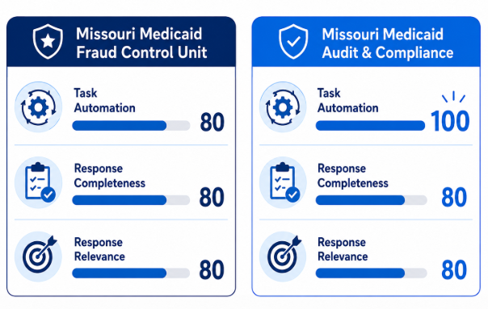

Final Information Product
The final intended deliverable for this project is an interactive, investigation-based analytics dashboard designed to assist stakeholders in preventing Medicare and Medicaid fraud, such as the Medicare Fraud Control Unit and Program Integrity. We present data-driven leads on potential suspicious DMEPOS suppliers and providers via informative visualizations, such as provider-level trend analyses of payments and billing behavior. Our final dashboard was implemented in Tableau, given our stakeholder’s established standard of reporting.
These insights are intended to support investigators in identifying suspicious patterns and enable more informed decision-making during investigation. Additionally, the dashboard incorporated an AI-powered agent that summarizes relevant external information, such as OIG news articles, regulatory filings, and Missouri Secretary of State business records, to provide supporting, case-relevant information and context about flagged providers and suppliers. Together, the dashboard and AI agent function as a decision-support tool that could potentially reduce losses, mitigate systemic risk, ensure compliance, and strengthen oversight.

Reflection
Looking back on our project process so far, if we were to do this again, we would start by defining a more marketable deliverable that is better suited for production deployment. Knowing upfront that the solution would need to integrate into an existing environment would change both how we design the deliverable and the questions we ask stakeholders. The outcome of a production-ready project likely would have shifted the project’s goals and even the stakeholders we chose. An overall improvement would also have been to define our research hypotheses earlier. We focused on the aims and deliverables, but we should have created a list of testable hypotheses based on the data we had available. Additionally, we should have focused on the reusability of our machine learning pipeline earlier on, since we created it initially in piecewise scripts rather than as a unified, modular pipeline.
If we had the necessary organizational and financial support, we would have pursued CMS Limited Data Sets for Researchers (which require a data use agreement). In an ideal situation, we would also have access to provider and supplier linked billing and, albeit unlikely, bank transactions. However, given the constraints of our capstone database and the administrative burden, we were limited to using public data. Thus, the resulting project used a granularity of data that is not industry standard and harder to discern signals from. Fraud is an extremely rare event which traditional ML algorithms struggle with already, so less aggregated data would have yielded better results. Additionally, data in our project is based on current data but not real-time, which would have improved the production- readiness of the ML pipeline. We also should have added the deactivation dates and additional provider addresses to the data, per conversations with our stakeholders. As a reach goal, a social media analysis of people mentioning Medicaid fraud online and additional web scraping of information for investigators to use would have been a great addition to the dashboard.

Why is this Data Science?
Healthcare fraud detection is an inherently data-driven problem, and this project addresses it as one. The scale of the challenge millions of provider-year records drawn from five distinct public datasets, an extreme class imbalance with confirmed fraud representing fewer than 0.03% of observations, and the operational requirement that outputs be explainable to non-technical investigators demands exactly the combination of skills the Data Science and Analytics discipline develops: rigorous data engineering, principled statistical modeling, thoughtful evaluation under real-world constraints, and the translation of analytical outputs into decisions. Every phase of this project reflects that full lifecycle, not as a theoretical exercise but as applied work built in direct collaboration with the Missouri Medicaid Fraud Control Unit and the Missouri Medicaid Audit and Compliance department.
The data engineering work alone represents a substantial contribution. Six public datasets CMS DMEPOS claims (by referring provider and by supplier, across two granularities each), CMS Open Payments (general and ownership interest), the OIG LEIE exclusion list, USDA rural-urban commuting codes, and the Missouri active Medicaid provider registry were acquired, cleaned, and unified into a single analytical spine spanning program years 2021 through 2023. These sources arrived in incompatible schemas, at different levels of granularity (transaction-level, provider-year-level, and ZIP-code-level), and with inconsistent handling of suppressed or missing values. Harmonizing them required entity resolution by NPI, specialty-level aggregation, geographic normalization using RUCA codes, temporal alignment to prevent data leakage across exclusion dates, and the construction of a medallion-architecture storage environment across two computing platforms. This is not preprocessing in the colloquial sense; it is the kind of complex, multi-source data integration that defines applied data engineering practice.
The modeling strategy directly confronts the defining statistical challenge of healthcare fraud: confirmed fraud labels are extremely sparse, and standard classifiers trained on such data will trivially default to predicting the majority class. Rather than treating this as a nuisance, the project treats it as a core research problem. The team evaluated multiple under sampling strategies including random under sampling across seven class ratios and the cluster-based CLEANSE algorithm using Stratified Group K-Fold cross-validation with NPI-level grouping constraints to prevent data leakage across years. Area Under the Precision-Recall Curve (AUPRC) was selected as the primary evaluation metric on principled grounds, following prior literature demonstrating that AUC-ROC is misleading under extreme class imbalance. Four supervised classifiers (XGBoost, Logistic Regression, and SVM) and unsupervised anomaly detector (INNE) were evaluated systematically, with the final configuration selected based on cross-fold stability rather than peak cross-validation score. This reflects mature statistical judgment: a model that is consistent across data splits is more trustworthy in deployment than one that achieves a high average score with high variance.
Explainability is treated as a first-class requirement, not an afterthought. The most predictive signals services per beneficiary and third-party manufacturer payment sums are presented alongside the score so that investigators can evaluate and challenge the model’s reasoning rather than accepting it as a black box. This approach directly addresses the documented reluctance of state and local agencies to adopt AI tools, which stems primarily from concerns about explainability and accountability. A model that can be interrogated and audited is one that can be used.
The final deliverable, an interactive Tableau dashboard integrated with an MCP-powered AI assistant demonstrates the communication and product development dimension of data science. The dashboard consolidates risk scores, ranked provider lists, billing trend visualizations, and natural-language querying of OIG and Missouri Secretary of State records into a single interface, removing the multi-tab friction investigators currently face. When stakeholders from MFCU and MMAC evaluated the AI assistant, task automation scored highest, confirming that the tool reduced manual effort in a way investigators immediately recognized as valuable. That kind of end-user validation iterative, operational, grounded in real investigative workflows is what separates a data science project from a modeling exercise. This project delivered a working system, tested it with its intended users, and received actionable feedback. That is the full data science lifecycle, completed.

References
[1] “Distinguishing Between Discretionary and Mandatory Spending | Congress.gov | Library of Congress.” Accessed: May 06, 2026. [Online]. Available: https://www.congress.gov/crs-product/IF13124
[2] “Fiscal Year 2025 Improper Payments Fact Sheet | CMS.” Accessed: May 05, 2026. [Online]. Available: https://www.cms.gov/newsroom/fact-sheets/fiscal-year-2025-improper-payments-fact-sheet
[3] “Durable Medical Equipment Fraud and Safeguards in Medicare,” Office of Inspector General | Government Oversight | U.S. Department of Health and Human Services. Accessed: May 02, 2026. [Online]. Available: https://oig.hhs.gov/reports/work-plan/browse-work-plan-projects/durable-medical-equipment-fraud-and-safeguards-in-medicare/
[4] “Office of Public Affairs | National Health Care Fraud Takedown Results in 324 Defendants Charged in Connection with Over $14.6 Billion in Alleged Fraud | United States Department of Justice.” Accessed: May 02, 2026. [Online]. Available: https://www.justice.gov/opa/pr/national-health-care-fraud-takedown-results-324-defendants-charged-connection-over-146
[5] “Medicare, Medicaid, and Children’s Health Insurance Programs: Announcement of Nationwide Temporary Moratoria on Enrollment of Durable Medical Equipment, Prosthetics, Orthotics, and Supplies (DMEPOS) Supplier Medical Supply Companies,” Federal Register. Accessed: May 02, 2026. [Online]. Available: https://www.federalregister.gov/documents/2026/02/27/2026-03971/medicare-medicaid-and-childrens-health-insurance-programs-announcement-of-nationwide-temporary
[6] “Medicaid | Medicaid.” Accessed: May 05, 2026. [Online]. Available: https://www.medicaid.gov/medicaid
[7] “Medicaid Fraud Control Units,” Office of Inspector General | Government Oversight | U.S. Department of Health and Human Services. Accessed: May 06, 2026. [Online]. Available: https://oig.hhs.gov/fraud/medicaid-fraud-control-units-mfcu/
[8] A. Du Preez, S. Bhattacharya, P. Beling, and E. Bowen, “Fraud detection in healthcare claims using machine learning: A systematic review,” Artificial Intelligence in Medicine, vol. 160, p. 103061, Feb. 2025, doi: 10.1016/j.artmed.2024.103061.
[9] J. Li, K.-Y. Huang, J. Jin, and J. Shi, “A survey on statistical methods for health care fraud detection,” Health Care Manage Sci, vol. 11, no. 3, pp. 275–287, Sep. 2008, doi: 10.1007/s10729-007-9045-4.
[10] L. Hernandez Aros, L. X. Bustamante Molano, F. Gutierrez-Portela, J. J. Moreno Hernandez, and M. S. Rodríguez Barrero, “Financial fraud detection through the application of machine learning techniques: a literature review,” Humanit Soc Sci Commun, vol. 11, no. 1, pp. 1–22, Sep. 2024, doi: 10.1057/s41599-024-03606-0.
[11] Office of Inspector General, “Medicare Fraud Strike Force,” Office of Inspector General. [Online]. Available: https://oig.hhs.gov/fraud/strike-force/
[12] Medicaid Agency Fraud Detection and Investigation Program, vol. 42. 1987. [Online]. Available: https://www.ecfr.gov/current/title-42/chapter-IV/subchapter-C/part-455/subpart-A
[13] S. Hatz, N. Dreksler, K. Wei, and B. Zhang, “Local US officials’ views on the impacts and governance of AI: Evidence from 2022 and 2023 survey waves,” 2025, arXiv. doi: 10.48550/ARXIV.2501.09606.
[14] D. Ruediger, R. MacDougall, S. Brachfield, D. Dechow, J. Parker, and J. Remy, “AI Adoption in Research Administration at Emerging Research Institutions,” Ithaka S+R, Mar. 2026. doi: 10.18665/sr.325252.
[15] M. Overton, B. Robison, and L. Sheneman, “TaMPERing with Large Language Models: A Field Guide for using Generative AI in Public Administration Research,” 2025, arXiv. doi: 10.48550/ARXIV.2504.01037.
[16] Umut Turgut YILDIRIM1* and Sena ŞAHİN2, “UNDERSTANDING THE MOTIVATIONS BEHIND ARTIFICIAL INTELLIGENCE (AI) ADOPTION IN LOCAL GOVERNMENTS: A QUALITATIVE STUDY OF POLITICIANS AND MANAGERS,” Mar. 2026, doi: 10.5281/ZENODO.18916705.
[17] J. M. Johnson and T. M. Khoshgoftaar, “Data-Centric AI for Healthcare Fraud Detection,” SN COMPUT. SCI., vol. 4, no. 4, p. 389, May 2023, doi: 10.1007/s42979-023-01809-x.
[18] R. Bauder and T. Khoshgoftaar, “Medicare Fraud Detection Using Random Forest with Class Imbalanced Big Data,” in 2018 IEEE International Conference on Information Reuse and Integration (IRI), Jul. 2018, pp. 80–87. doi: 10.1109/IRI.2018.00019.
[19] M. Tajrobehkar et al., “Utilization Analysis and Fraud Detection in Medicare via Machine Learning,” Jan. 01, 2025, medRxiv. doi: 10.1101/2024.12.30.24319784.
[20] M. Bairy, B. Muniyal, and N. P. Shetty, “Enhancing healthcare data integrity: fraud detection using unsupervised learning techniques,” International Journal of Computers and Applications, vol. 46, no. 11, pp. 1006–1019, Nov. 2024, doi: 10.1080/1206212X.2024.2408262.
[21] Q. Liu and M. Vasarhelyi, “Healthcare fraud detection: A survey and a clustering model incorporating Geo-location information,” 2013.
[22] Z. Hamid, F. Khalique, S. Mahmood, A. Daud, A. Bukhari, and B. Alshemaimri, “Healthcare insurance fraud detection using data mining,” BMC Medical Informatics and Decision Making, vol. 24, no. 1, p. 112, Apr. 2024, doi: 10.1186/s12911-024-02512-4.
[23] USA and S. Sethi, “Risk Scoring Models in Healthcare Data Analytics: A Practitioner’s Perspective on Machine Learning, Interpretability, and Regulatory Compliance,” Prog Med Sci, pp. 1–4, Feb. 2025, doi: 10.47363/PMS/2025(9)E173.
[24] S. S. Kaddi and M. M. Patil, “Ensemble learning based health care claim fraud detection in an imbalance data environment,” Indonesian Journal of Electrical Engineering and Computer Science, vol. 32, no. 3, pp. 1686–1694, Dec. 2023, doi: 10.11591/ijeecs.v32.i3.pp1686-1694.
[25] M. El-Lakany and D. Chrimes, “Big data analytic of US Medicare Claims of healthcare service informatics and billing fraud,” in 2024 IEEE International Conference on Big Data (BigData), Dec. 2024, pp. 4013–4022. doi: 10.1109/BigData62323.2024.10825957.
[26] J. T. Hancock, R. A. Bauder, H. Wang, and T. M. Khoshgoftaar, “Explainable machine learning models for Medicare fraud detection,” J Big Data, vol. 10, no. 1, p. 154, Oct. 2023, doi: 10.1186/s40537-023-00821-5.
[27] N. Kumaraswamy, M. K. Markey, J. C. Barner, and K. Rascati, “Feature engineering to detect fraud using healthcare claims data,” Expert Systems with Applications, vol. 210, p. 118433, Dec. 2022, doi: 10.1016/j.eswa.2022.118433.
[28] M. Herland, T. M. Khoshgoftaar, and R. A. Bauder, “Big Data fraud detection using multiple medicare data sources,” J Big Data, vol. 5, no. 1, p. 29, Dec. 2018, doi: 10.1186/s40537-018-0138-3.
[29] A. Fernández, S. del Río, N. V. Chawla, and F. Herrera, “An insight into imbalanced Big Data classification: outcomes and challenges,” Complex Intell. Syst., vol. 3, no. 2, pp. 105–120, Jun. 2017, doi: 10.1007/s40747-017-0037-9.
[30] G. S. Hida and A. C. Alves Do Nascimento, “Overview of machine learning in class imbalance scenarios: Trends, challenges, and approaches,” Expert Systems with Applications, vol. 298, p. 129592, Mar. 2026, doi: 10.1016/j.eswa.2025.129592.
[31] K. Fujiwara et al., “Over- and Under-sampling Approach for Extremely Imbalanced and Small Minority Data Problem in Health Record Analysis,” Front Public Health, vol. 8, p. 178, May 2020, doi: 10.3389/fpubh.2020.00178.
[32] M. Herland, R. A. Bauder, and T. M. Khoshgoftaar, “The effects of class rarity on the evaluation of supervised healthcare fraud detection models,” J Big Data, vol. 6, no. 1, p. 21, Dec. 2019, doi: 10.1186/s40537-019-0181-8.
[33] R. Bhattacharya, R. De, A. Chakraborty, and R. Sarkar, “Clustering Based Undersampling for Effective Learning from Imbalanced Data: An Iterative Approach,” SN COMPUT. SCI., vol. 5, no. 4, p. 386, Apr. 2024, doi: 10.1007/s42979-024-02717-4.
[34] M. Bach, P. Trofimiak, D. Kostrzewa, and A. Werner, “CLEANSE – Cluster-based Undersampling Method,” Procedia Computer Science, vol. 225, pp. 4541–4550, Jan. 2023, doi: 10.1016/j.procs.2023.10.452.
[35] L. Hernandez Aros, L. X. Bustamante Molano, F. Gutierrez-Portela, J. J. Moreno Hernandez, and M. S. Rodríguez Barrero, “Financial fraud detection through the application of machine learning techniques: a literature review,” Humanit Soc Sci Commun, vol. 11, no. 1, pp. 1–22, Sep. 2024, doi: 10.1057/s41599-024-03606-0.
[36] Z. Bolukbasi, H. Yurtoglu, E. Kugu, and H. Cukurtepe, “Insurance Fraud Detection Using Machine Learning and XAI Algorithms,” in 2025 IEEE International Conference on Electro Information Technology (eIT), Valparaiso, IN, USA: IEEE, May 2025, pp. 463–468. doi: 10.1109/eIT64391.2025.11103653.
[37] M. Tajrobehkar et al., “Utilization Analysis and Fraud Detection in Medicare via Machine Learning,” Jan. 01, 2025, medRxiv. doi: 10.1101/2024.12.30.24319784.
[38] J. M. Johnson and T. M. Khoshgoftaar, “Data-Centric AI for Healthcare Fraud Detection,” SN COMPUT. SCI., vol. 4, no. 4, p. 389, May 2023, doi: 10.1007/s42979-023-01809-x.
[39] R. Bauder and T. Khoshgoftaar, “Medicare Fraud Detection Using Random Forest with Class Imbalanced Big Data,” in 2018 IEEE International Conference on Information Reuse and Integration (IRI), Jul. 2018, pp. 80–87. doi: 10.1109/IRI.2018.00019.
[40] G. Ke et al., “LightGBM: a highly efficient gradient boosting decision tree,” in Proceedings of the 31st International Conference on Neural Information Processing Systems, Long Beach California USA: Curran Associates Inc., Dec. 2017, pp. 3149–3157. [Online]. Available: https://proceedings.neurips.cc/paper_files/paper/2017/file/6449f44a102fde848669bdd9eb6b76fa-Paper.pdf
[41] R. Bauder, R. Da Rosa, and T. Khoshgoftaar, “Identifying Medicare Provider Fraud with Unsupervised Machine Learning,” in 2018 IEEE International Conference on Information Reuse and Integration (IRI), Salt Lake City, UT: IEEE, Jul. 2018, pp. 285–292. doi: 10.1109/IRI.2018.00051.
[42] H. De Meulemeester, F. De Smet, J. Van Dorst, E. Derroitte, and B. De Moor, “Explainable unsupervised anomaly detection for healthcare insurance data,” BMC Med Inform Decis Mak, vol. 25, no. 1, p. 14, Jan. 2025, doi: 10.1186/s12911-024-02823-6.
[43] T. R. Bandaragoda, K. M. Ting, D. Albrecht, F. T. Liu, Y. Zhu, and J. R. Wells, “Isolation‐based anomaly detection using nearest‐neighbor ensembles,” Computational Intelligence, vol. 34, no. 4, pp. 968–998, Nov. 2018, doi: 10.1111/coin.12156.
[44] H. Xiang et al., “OptIForest: Optimal Isolation Forest for Anomaly Detection,” Jun. 23, 2023, arXiv: arXiv:2306.12703. doi: 10.48550/arXiv.2306.12703.
[45] F. T. Liu, K. M. Ting, and Z.-H. Zhou, “Isolation Forest,” in 2008 Eighth IEEE International Conference on Data Mining, 2008, pp. 413–422. doi: 10.1109/ICDM.2008.17.
[46] Z. Li, Y. Zhao, X. Hu, N. Botta, C. Ionescu, and G. H. Chen, “ECOD: Unsupervised Outlier Detection Using Empirical Cumulative Distribution Functions,” IEEE Trans. Knowl. Data Eng., vol. 35, no. 12, pp. 12181–12193, Dec. 2023, doi: 10.1109/TKDE.2022.3159580.
[47] F. Carcillo, Y.-A. Le Borgne, O. Caelen, Y. Kessaci, F. Oblé, and G. Bontempi, “Combining unsupervised and supervised learning in credit card fraud detection,” Information Sciences, vol. 557, pp. 317–331, May 2021, doi: 10.1016/j.ins.2019.05.042.
[48] Z. Hamid, F. Khalique, S. Mahmood, A. Daud, A. Bukhari, and B. Alshemaimri, “Healthcare insurance fraud detection using data mining,” BMC Medical Informatics and Decision Making, vol. 24, no. 1, p. 112, Apr. 2024, doi: 10.1186/s12911-024-02512-4.
[49] C. L. Calvert and T. M. Khoshgoftaar, “Threshold Based Optimization of Performance Metrics with Severely Imbalanced Big Security Data,” in 2019 IEEE 31st International Conference on Tools with Artificial Intelligence (ICTAI), Portland, OR, USA: IEEE, Nov. 2019, pp. 1328–1334. doi: 10.1109/ICTAI.2019.00184.
[50] K. Boyd, V. Santos Costa, J. Davis, and C. D. Page, “Unachievable Region in Precision-Recall Space and Its Effect on Empirical Evaluation,” Proc Int Conf Mach Learn, vol. 2012, p. 349, Dec. 2012.
[51] K. Boyd, K. H. Eng, and C. D. Page, “Area under the Precision-Recall Curve: Point Estimates and Confidence Intervals,” in Advanced Information Systems Engineering, vol. 7908, C. Salinesi, M. C. Norrie, and Ó. Pastor, Eds., Berlin, Heidelberg: Springer Berlin Heidelberg, 2013, pp. 451–466. doi: 10.1007/978-3-642-40994-3_29.
[52] S. Lundberg and S.-I. Lee, “A Unified Approach to Interpreting Model Predictions,” 2017, arXiv. doi: 10.48550/ARXIV.1705.07874.
[53] S. Borsci et al., “The Chatbot Usability Scale: the Design and Pilot of a Usability Scale for Interaction with AI-Based Conversational Agents,” Pers Ubiquit Comput, vol. 26, no. 1, pp. 95–119, Feb. 2022, doi: 10.1007/s00779-021-01582-9.
[54] Centers for Medicare & Medicaid Services, “General Payment Data – Detailed Dataset.” Jan. 27, 2026. [XSLX]. Available: openpaymentsdata.cms.gov
[55] A. P. Rodriguez Müller, L. Tangi, and A. Lerusse, “Understanding the Adoption of Artificial Intelligence in Local Government Decision‐Making: The Influence of Institutional Pressures and Managerial Perceptions,” Public Administration, p. padm.70033, Nov. 2025, doi: 10.1111/padm.70033.
[56] G. Van Capelleveen, M. Poel, R. M. Mueller, D. Thornton, and J. Van Hillegersberg, “Outlier detection in healthcare fraud: A case study in the Medicaid dental domain,” International Journal of Accounting Information Systems, vol. 21, pp. 18–31, Jun. 2016, doi: 10.1016/j.accinf.2016.04.001.
[57] U.S. Department of Health and Human Services, Office of Inspector General, “List of Excluded Individuals/Entities (LEIE) Database and Supplement Downloads.” Accessed: Oct. 03, 2025. [CSV]. Available: https://oig.hhs.gov/exclusions/leie-database-supplement-downloads/
[58] “Medicare Durable Medical Equipment by Referring Provider | CMS Data.” Accessed: May 13, 2026. [Online]. Available: https://data.cms.gov/provider-summary-by-type-of-service/medicare-durable-medical-equipment-devices-supplies/medicare-durable-medical-equipment-devices-supplies-by-referring-provider
[59] “Medicare Durable Medical Equipment by Provider & Service Data | CMS Data.” Accessed: May 13, 2026. [Online]. Available: https://data.cms.gov/provider-summary-by-type-of-service/medicare-durable-medical-equipment-devices-supplies/medicare-durable-medical-equipment-devices-supplies-by-referring-provider-and-service
[60] “HCPCS Codes & Modifiers Lookup, HCPCS Codes List - Codify by AAPC.” Accessed: May 13, 2026. [Online]. Available: https://www.aapc.com/codes/hcpcs-codes-range/0
[61] “Medicare Durable Medical Equipment by Supplier Data | CMS Data.” Accessed: May 13, 2026. [Online]. Available: https://data.cms.gov/provider-summary-by-type-of-service/medicare-durable-medical-equipment-devices-supplies/medicare-durable-medical-equipment-devices-supplies-by-supplier
[62] “Medicare Durable Medical Equipment by Supplier & Service Data | CMS Data.” Accessed: May 13, 2026. [Online]. Available: https://data.cms.gov/provider-summary-by-type-of-service/medicare-durable-medical-equipment-devices-supplies/medicare-durable-medical-equipment-devices-supplies-by-supplier-and-service

